Chapter 5: Sensor Array, State Estimation, and PCB Interface

# Mini Abstract

The onboard sensor array of the drone includes an altimeter sensor for high altitude tracking, an IMU sensor for crash detection and positional state estimation, a GPS module for autonomous path following, and a pressure sensor for helium lift bag leakage detection. The sensor array communicates with the PIC32 microcontroller via I2C, SPI, UART, Input Capture, and Output Compare pins. The sensor array is built onto a single PCB to enable PCB interface between sensors and the microcontroller and processor where the processor can calculate the state. Voltage regulators are implemented within the PCB to distribute power from the drone’s onboard battery to the onboard ICs with appropriate voltages. Analog electronics, such as the 3 phase motors, transmitters, and receivers, are connected to the PCB via pinouts to reduce EMF interference with the onboard digital sensor array. The PCB is custom designed for our drone to integrate the sensors, voltage regulators, Raspberry Pi microprocessor ICs, and PIC32 microcontroller into one board, effectively reducing the drone mass and reducing electrical clutter.

# 

# Chapter Outline

Develop the chapter outline here. Should become very detailed and broken down to paragraph level. Remember, if we invest time and effort into making a detailed outline, the actual writing will be far easier since we understand the flow and structure before we lay out the details. Before even writing a subsection, take the time to outline that subsection in the chapter outline. A lot of writing is in the layout. Remember to update this chapter in the Master Outline file so we can all keep track of the full outline of the report, it's large so breaking it up this way should help everyone keep track of each other's ideas and work.

Chapter 5:

* Section 1: Sensor Array
  + Subsection 1: HCSR04 Ultrasonic sensor
    - Interface between ultrasonic sensors and PIC32 pins using Input Capture
    - Description of trigger and echo pins
    - Digital sensor
  + Subsection 2: MPL3115A2 Barometric and Temperature Sensor for High Altitude Tracking
    - I2C interface between altimeter and PIC32 using dedicated I2C pins
    - Two interrupt driven pins
  + Subsection 3: ICM-20948 9-DoF IMU
    - I2C
    - Interrupt driven pin
  + Subsection 4: Honeywell MicroPressure Board mount Pressure Sensor for ballon leakage detection
    - I2C interface between barometer and PIC32 using dedicated I2C pins
    - Polling
  + Subsection 4: MT3339 GPS Module for autonomous flight
    - UART interface between GPS Module to dedicated UART pins on PIC32
    - Polling
* Section 2: State Estimation
  + State estimation using accelerometer data from IMU
* Section 3: PCB Interface
  + PCB Trace Width
  + I2C bus between Sensor Array to PIC32
  + SPI bus sensor array data and state machine estimation between PIC32 microcontroller and Raspberry Pi CM3+ microprocessor
  + Output Capture Motor PWM pinout from PIC32
  + GPIO Servo PWM pinout from PIC32

# Chapter 5 Draft

The onboard sensor array of the drone includes an altimeter sensor for high altitude tracking, an IMU sensor for crash detection and positional state estimation, a GPS module for autonomous path following, and a pressure sensor for helium lift bag leakage detection. The sensor array communicates with the PIC32 microcontroller via I2C, SPI, UART, Input Capture, and Output Compare pins. The sensor array is built onto a single PCB to enable PCB interface between sensors and the microcontroller and processor where the processor can calculate the state. Voltage regulators are implemented within the PCB to distribute power from the drone’s onboard battery to the onboard ICs with appropriate voltages. Analog electronics, such as the 3 phase motors, transmitters, and receivers, are connected to the PCB via pinouts to reduce EMF interference with the onboard digital sensor array. The PCB is custom designed for our drone to integrate the sensors, voltage regulators, Raspberry Pi microprocessor ICs, and PIC32 microcontroller into one board, effectively reducing the drone mass and reducing electrical clutter.

## 5.1 Sensor Array

5.1.1 HCSR04 Ultrasonic Sensors

To satisfy STR 4.2.1, which was to use the ultrasonic sensors to detect constant height of 1m, the HCSR04 was chosen. The ultrasonic sensors would be used to detect distance from the drone. To configure the ultrasonic sensor, the following timing diagram from Elecfreaks was used as reference[70]:

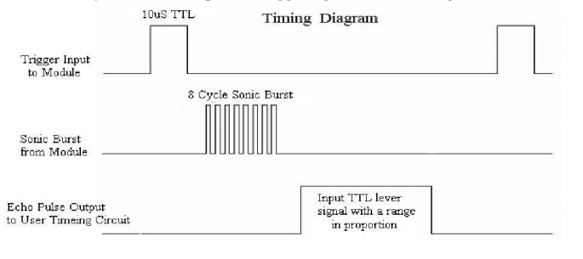

Fig. 5.1. Ultrasonic Timing Diagram

To begin, the microcontroller would send a 10us pulse to the trigger input of the ultrasonic sensor, which is shown in the first signal of the timing diagram. Following this, the sensor would send out an 8 cycle sonic burst at 40kHz, shown in the second signal of the diagram, and immediately raise its echo pin, as shown in the third signal of the diagram, to indicate the sensor sent out a ping. Once that ping hit something and returned to the sensor, the sensor would lower its echo pin. By connecting the echo pin to the microcontroller and using the microcontroller to time the length at which the echo pin remained high, the amount of time the ping took to get back to the sensor could be determined. Knowing this and the speed at which sound travels, 343m/s, the distance of the object from the sensor could be calculated by multiplying the time, divided by 2 since the ping both travels to the object and back, by the speed. Between each trigger input from the microcontroller, 60ms cycles were recommended by the manufacturer in order to prevent a new input signal from going out to the sensor before the old echo signal came back.

In order to implement this into software, the PIC32’s Timers and Input Captures were utilized (see Chapter 4 for description on Timers and Input Captures). With the ultrasonic sensor, the Input Capture pin would need to capture the value of a Timer when the echo pin went high, and then once again when it went low, and subtract the Timer values to find the total amount of time that had gone by.

The following is a sample flowchart of how a standard run with the PIC32 and ultrasonic sensor goes:

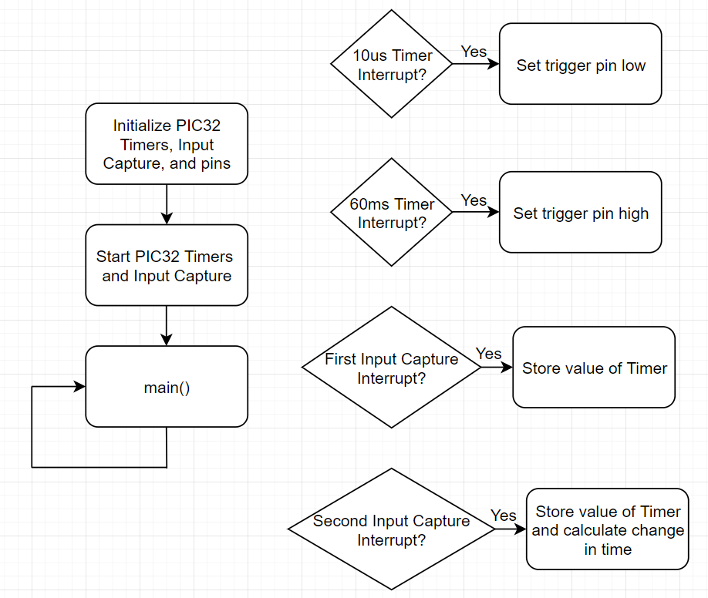

Fig. 5.2. Sample Run with the PIC32 and Ultrasonic Sensor

In the initialization phase, two Timers, Timer 2 and Timer 3 are initialized to be 60ms and 10us timers by setting Timer 2’s pre-scalar and PR to 256 and 9375 respectively Timer 3’s pre-scalar and PR to 16 and 25 respectively. Input Capture 1 is set up with Timer 2 as its Timer source, and so that it triggers an interrupt on every rising and falling edge of the echo pin. The pin from the PIC32 going to the ultrasonic trigger input is configured as an output pin with a starting value of 1, while the pin from the ultrasonic echo output to the PIC32 is configured as an input pin with a starting value of 0. The Timers and Input Capture are then started, and the program enters the main loop. Once the 10us Timer goes off and triggers an interrupt, the trigger pin is set to 0. If the 60ms Timer goes off and triggers an interrupt, the trigger pin is set back to 1. When the ultrasonic sensor sends out a ping and raises the echo pin, the first Input Capture interrupt goes off and triggers an interrupt, and the value of Timer 2 is stored. When the ping comes back to the ultrasonic sensor and the echo pin is lowered, the second Input Capture interrupt goes off and triggers an interrupt, and the value of Timer 2 is stored once again, and the first Timer 2 value is subtracted from the second Timer 2 value to find the change in time of the ping being sent and received. However, the values of the Timer are not equivalent to real-time, since they run off of the Peripheral Clock. To get this time in real-time, you need to multiply by the real-time you set the Timer to, which would be 60ms or 10us in this case, and divide by the PR of the Timer. This gives you the actual time of the ping, and by dividing by two to find the time taken for just the ping to be sent out from the ultrasonic sensor and reach some object, and then by multiplying by the speed of sound, the distance of the object from the sensor can be determined.

The HCSR04 ultrasonic sensor’s trigger is soldered to the digital pins from the PIC32MX340F512H microcontroller. With a combined total of 4 ultrasonic trigger pins, each was soldered to their own digital output pins from the microcontroller. The microcontroller must output a logic high of at least 10us to command the ultrasonic sensor to start sampling distance.

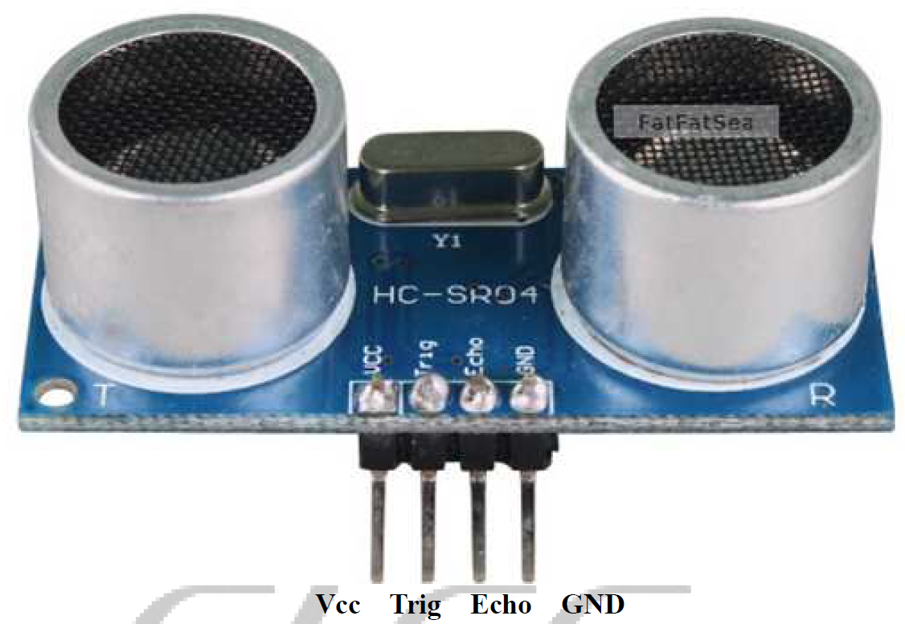

Fig. 5.3. HCSR04 Ultrasonic Sensor Breakout Board

Each echo pin is soldered to an Input Capture pin of the PIC32MX340F512H to have interrupt driven logic high time recording of each ultrasonic sensor. The logic high duration determines the distance between the object to the sensor.

The ultrasonic sensor itself outputs digital signals via the trigger and echo pins and only needs 5V to Vcc to power and ground pin. The algorithm to calculate the time taken for the ultrasonic burst is done on a separate breakout board on the ultrasonic sensor itself with ICs on the back of the breakout board [21].

To connect the pinouts from the ultrasonic sensor to the PCB, 4 wires are used to connect the Vcc, Trig, Echo, and GND pin to the pinout holes shown below in figure 5.4.

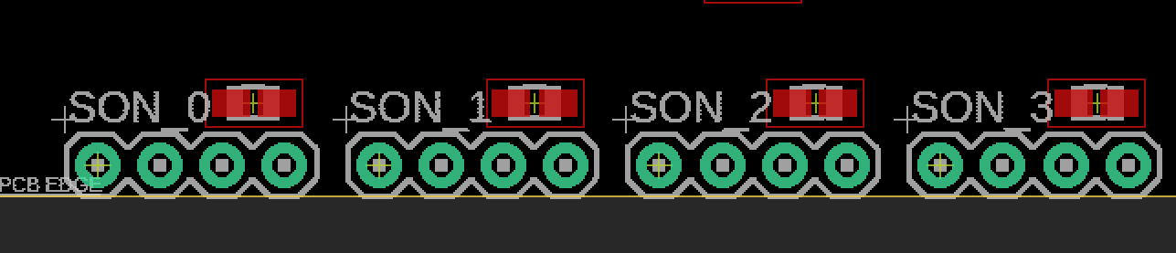

Figure 5.4. PCB pinout for 4 HCSR04 Ultrasonic Sensors

4 ultrasonic sensor modules are connected to the PCB board, with each module connected to a set of 4 through hole pinouts. A zoomed in diagram of each set of ultrasonic pinout is shown in figure 3 below.

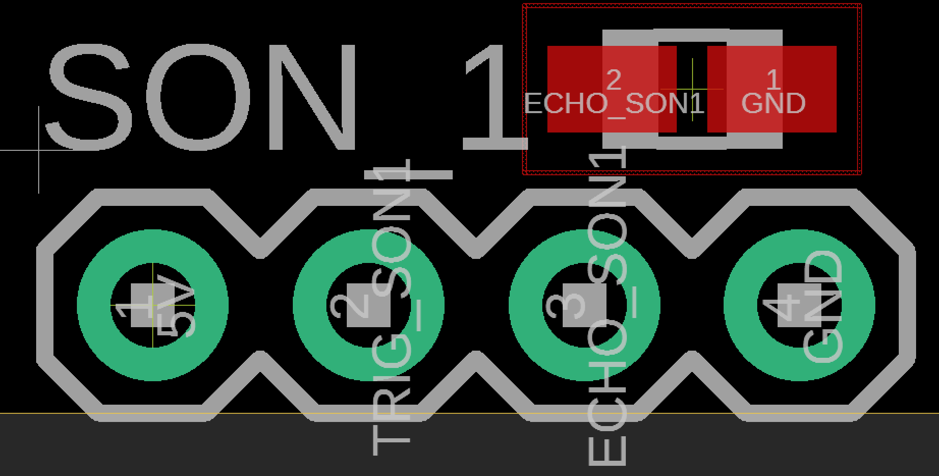

Fig. 5.5. 4 Through Hole Pinouts on PCB for HCSR04 Ultrasonic Sensor

Each set of ultrasonic sensor pinouts on the PCB is arranged the same way as in figure 5.3. With the 5V pinout on the left most side soldered to the wire connecting to HCSR04, for power to Vcc pin on the HCSR04 pinout. The TRIG_SON(n) pin on figure 5.3 is soldered to the wire connecting the TRIG_SON(n) pin of figure 5. 3, followed by the ECHO_SON(n) soldered to the wire connecting the Echo pin of HCSR04. Lastly the GND pin is soldered to the wire connecting to the GND pin of HCSR04.

5.1.2 MPL3115A2 Altimeter (Barometric and temperature sensor)

To satisfy STR 4.2.2, which was to use the altimeter to monitor altitudes above 4m, the MPL3115A2 altimeter was chosen. The altimeter would be used to measure elevation of the drone. The altimeter uses I2C, so an I2C procedure had to be written on the PIC32, which has I2C hardware on it.

I2C is one of the other essential pieces of hardware on the PIC32 which allows for serial transmission as both a master and a slave. The PIC32 I2C module has seven special function registers ranging in purpose of controlling the module, checking the state of it, setting the baud rate of the SDA line, and transmitting and receiving data. To follow the standard I2C procedure, the following transmission diagram from the PIC32 I2C datasheet was used to write the procedure[71]:

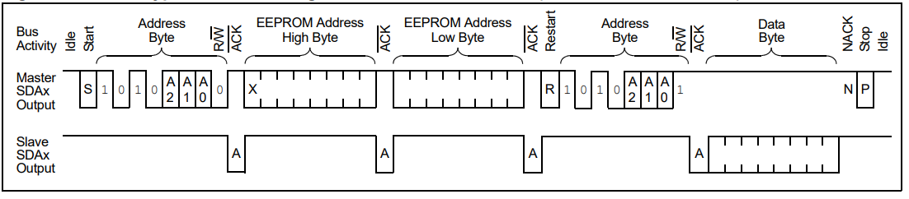

Fig. 5.6. I2C Procedure

In this example the master, the PIC32, is reading from the slave. The PIC32 first sends a start bit along the I2C SDA line to indicate start of transmission. It then sends the address of the slave as a byte to identify it, and waits until the slave acknowledges and responds, which will happen when the slave pulls the SDA line low. Next, the master sends out the address of the specific register it wishes to read or write from the slave, and once again waits for acknowledgement from the slave. Then, the PIC32 sends out a restart signal to indicate that it is about to read or write from the slave. It then sends the address of the slave once again, with the last bit (least-significant bit) signifying whether the PIC32 is reading or writing, 1 for read and 0 for write, which in this case is 1 for reading. It then waits for another acknowledgment from the sensor, and reads the data byte being sent from the slave. If the PIC32 were writing to the sensor, the last bit of the slave address would be 0, and it would write a byte of data along the SDA line. Finally, the PIC32 sends acknowledgement back to the slave to indicate success or failure of reading/writing, and sends a stop signal to indicate it is done.

To implement this in software, the most important components of the I2C module that needed to be configured were the control, status, baud rate, transmit data, and receive data registers. The control register sets the operational control of the module, most importantly being the enable bit to turn on the module. The status register is self-regulated, and can be checked upon to see the acknowledgement status and transmit and receive status. The baud rate register sets the baud rate of the SCL line, which is calculated based on the Peripheral Clock and is found by using this equation from the datasheet:

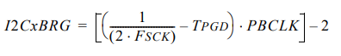

Equation 5. 1. I2C Baud Rate Generator

For a TPGD of 104ns, which is the delay given by the datasheet, a PBCLK of 40MHz, the Peripheral Clock of the PIC32, and the desired FSCK of 100kHz for the SCL line, the BRG, or baud rate generator value to be written to the baud rate register, should be 0x02C. Finally, the transmit data and receive data registers are used to send and receive a byte of data.

The altimeter also had a dedicated interrupt pin that would let the PIC32 know when new data was ready to read from, and could be utilized with the PIC32’s Change Notification functionality. The PIC32’s Change Notification allows the PIC32 to trigger an interrupt when the state of a pin changes. The main registers are the control register, which configures the change notification module to be on or off, as well as the enable register, which contains which pins should be tracked.

To read from the altimeter, the following flowchart from the altimeter datasheet was referenced[72]:

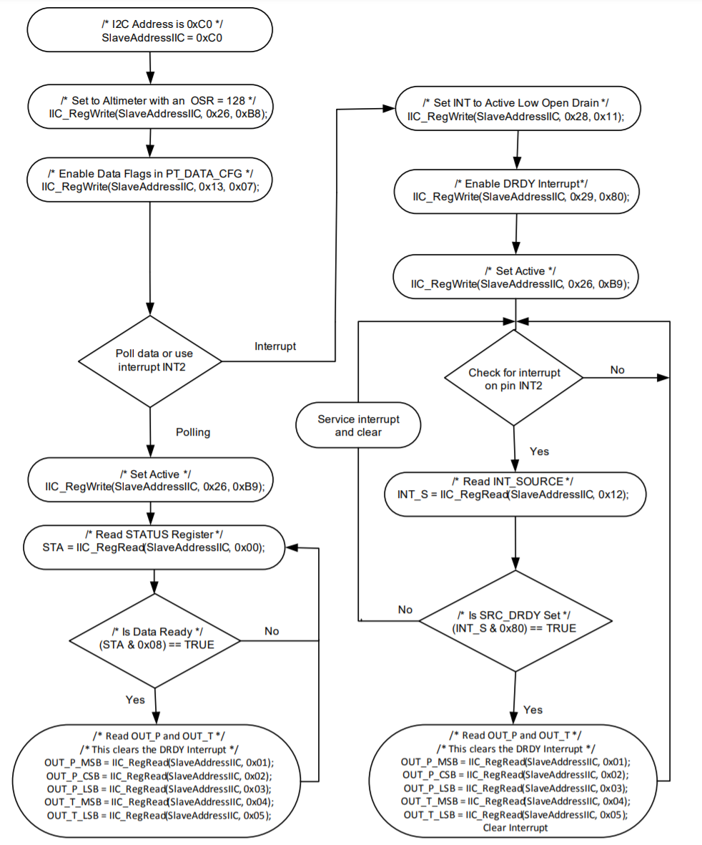

Fig. 5.7. Altimeter Flowchart

To start, the altimeter is configured to 128x sample rate and to log new pressure data, and convert it to altitude by writing to its Control Register 1 and PT Data Configuration Register. Then, for the interrupt procedure, Control Register 3 and Control Register 4 are configured to trigger an interrupt on new data, followed by writing to Control Register 1 to start the altimeter. When the altimeter reads new data and triggers an interrupt, the Pressure Data Out registers are read from, with Pressure Data Out being divided into three registers. To convert the Pressure Data Out values from bits to a signed fractional number, the most significant byte must be left shifted by 24 bits into a 32-bit variable, logically OR’d with the central significant byte left shifted by 16 bits, and logically OR’d with the least significant byte left shifted by 8 bits. This value multiplied by 65536 gives the altitude in meters.

The following is a sample flowchart of how a standard run with the PIC32 and altimeter goes:

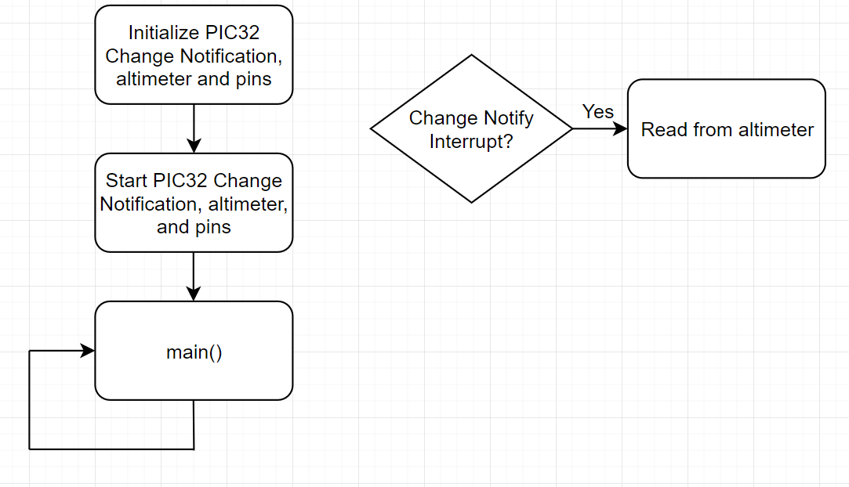

Fig. 5.8. Sample Run with the PIC32 and Altimeter

In the initialization phase, the Change Notification module is configured with the desired pins to keep track of, and the pin itself is configured as an input, and is given a starting value of 0. The altimeter is also initialized to max sample rate and to log pressure data and trigger an interrupt when new data is ready. The Change Notification module is then turned on, the altimeter is enabled, and the program enters the main loop. When the altimeter has new data ready, it will trigger its interrupt pin, and enable the Change Notification interrupt for the pin connected to the PIC32. In this interrupt, the proper registers from the altimeter are read from (as described in the flowchart earlier), and the data from the sensor is processed.

The altimeter uses I2C pinout (SDA and SCL) to communicate with the PIC32 microcontroller to provide pressure data to enable high altitude tracking where the ultrasonic sensors cannot track. As shown in figure 5.19 below.

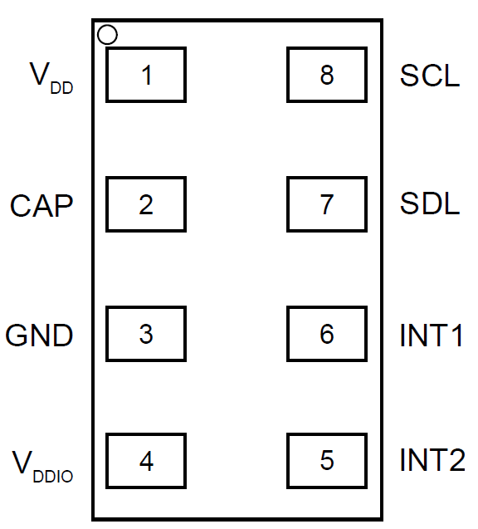

Fig. 5.9. MPL3115A2 Altimeter LGA Pinout

VDD/pin 1 and VDDIO/pin 4 in figure 5.9 are connected to the 3.3V plane of the PCB. VDD/pin 1 is the operating supply voltage and VDDIO/pin 4 is the supply voltage for SDL, SCL, INT1, and INT2 pins. The CAP/pin 2 is connected to an external 0.1uF capacitor as recommended by the datasheet[22]. The SCL/pin 8 or clock line of I2C is connected to the PIC32 microcontroller’s SCL1/pin37, the wiring is done through the PCB trace which will be explained in section 3 of this chapter. The SDL/pin7 of the altimeter is connected to the SDA1/pin of the PIC32. The INT1/pin6 is connected to RB0/pin16 of PIC32, its purpose is to send a logic high for interrupt driven data sampling of the atmospheric pressure. INT2/pin5 is connected to RB1/pin15 of the PIC32, INT2 is programmable via I2C bus to MPL3115A2 to trigger interrupt when a certain pressure has been detected/reached. It is recommended by the manufacturer’s datasheet to have a 100nF and 10uF capacitor placed in parallel to bypass the internal regulator as shown in figure 5.10 below.

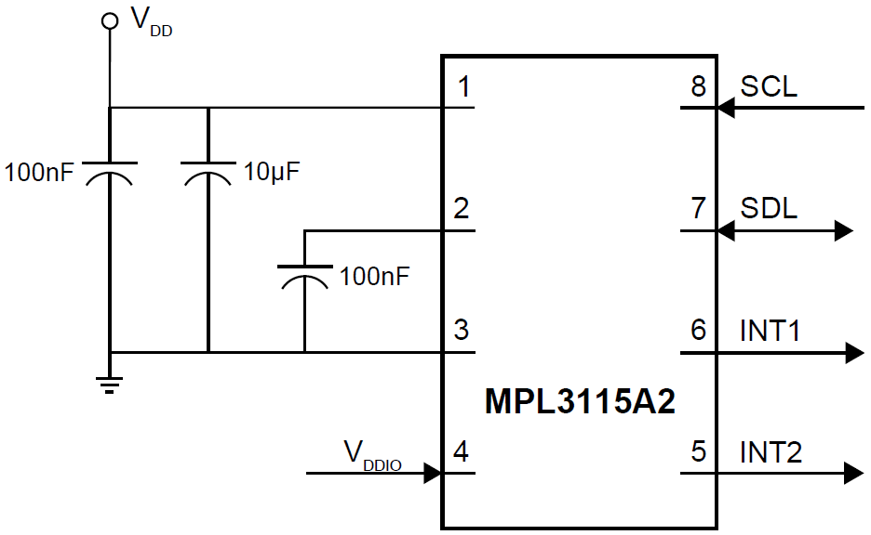

Fig. 5.10. MPL3115A2 Altimeter Typical Application Diagram

5.1.3 ICM-20948 9DoF IMU

To satisfy STR 4.3.1, which was to use the IMU sensor to detect the orientation of the drone, the ICM-20948 9DoF IMU was chosen. To read from the IMU sensor, a similar procedure to the altimeter’s was followed. The IMU sensor uses I2C as a form of communication, and had a dedicated interrupt pin that would signal when new data was ready, which meant the PIC32’s Change Notification module would once again be used. The main registers used in the IMU sensor were the LP_CONFIG, INT_PIN_CFG, INT_ENABLE, ACCEL_OUT, GYRO_OUT, and H registers. The LP_CONFIG register determined the mode of operation, while the INT_PIN_CFG and INT_ENABLE registers configured and set the interrupt trigger. The ACCEL_OUT, GYRO_OUT, and H registers were each three pairs of registers that contained a 16-bit value over a single pair representing the acceleration, rotational speed, or magnetic field in one of x, y, or z directions[73].

The following is a sample flowchart of how a standard run with the PIC32 and IMU goes:

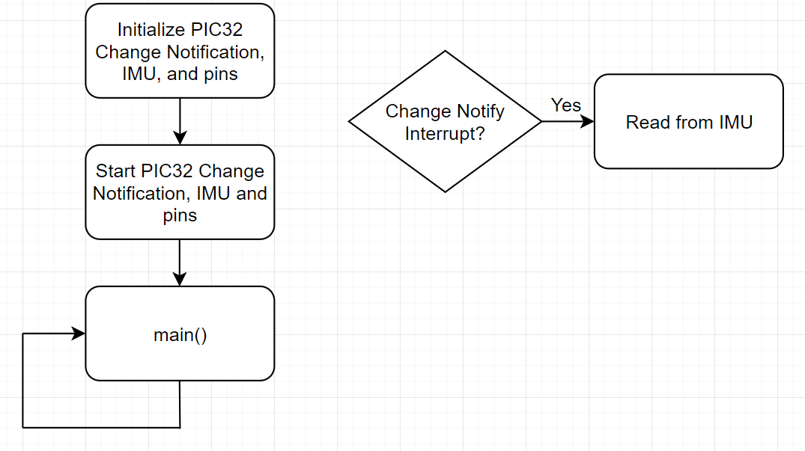

Fig. 5.11. Sample Run with the PIC32 and IMU

In the initialization phase, the Change Notification module is configured with the desired pins to keep track of, and the pin itself is configured as an input, and is given a starting value of 0. The IMU is also initialized to max sample rate and to log acceleration, rotational speed, and magnetic field and trigger an interrupt when new data is ready. The Change Notification module is then turned on, and the program enters the main loop. When the IMU has new data ready, it will trigger its interrupt pin, and enable the Change Notification interrupt for the pin connected to the PIC32. In this interrupt, the proper registers from the IMU are read from (as described in the earlier), and the data from the sensor is processed.

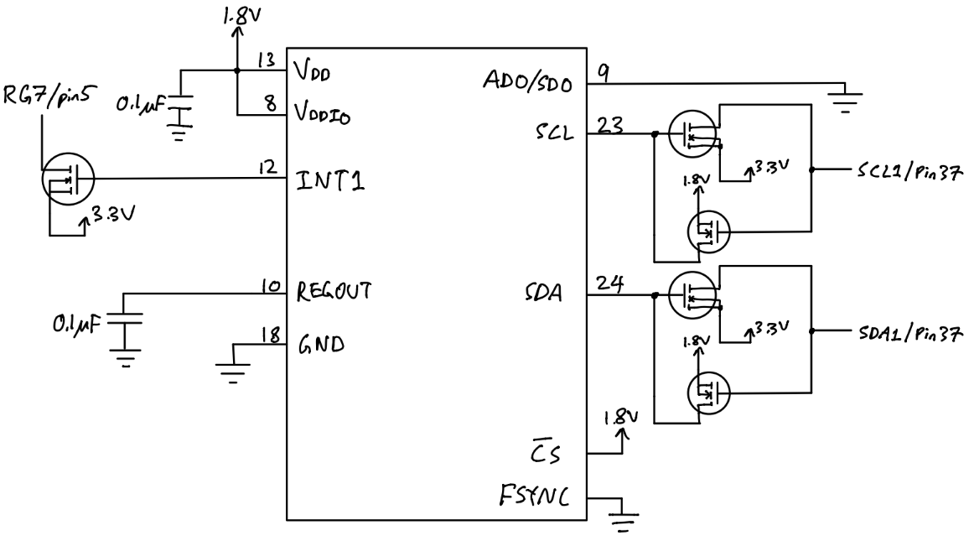

Fig. 5.12. ICM-20948 IMU Pinout to PIC32 Schematic

The ICM-20948 IMU’s VDDIO only allows a maximum voltage of 1.95V, this also means the logic high of I2C bus is limited to 1.8V. Two logic level converters are implemented in the PCB to convert 1.8V output from SCL and SDA to 3.3V of the IMU, as shown in figure 5.12 on pin 23 and 24, into 3.3V signal into SCL1 and SDA1 pins of the PIC32 microcontroller. The PIC32 microcontroller outputs 3.3V I2C signals to the IMU, so another two logic level converters are implemented to convert 3.3V signal to 1.8V into the IMU.

An interrupt driven output pin called INT1/pin12 of the IMU is connected to a logic level converter to output 3.3V interrupt to RG6/pin 5 of the microcontroller, which enables interrupt driven accelerometer data.[23]

5.1.4 MT3339 GPS Module

The GPS module satisfies STR 4.1.1 for location tracking via UART to PIC32 microcontroller, accurate within 5 meters and a sampling rate of at least 3Hz.

The GPS module communicates through the use of a UART, and could be interfaced with using the PIC32’s UART. In addition, the GPS module has a fix pin, which outputs a high signal when the GPS module locks onto a satellite, and could be used with the PIC32’s Change Notification functionality to detect when to start taking measurements from the GPS module[74].

The PIC32’s UART is another essential piece of hardware on the PIC32 that allows for serial communication. The main registers within the UART module are the mode, status and control, transmit and receive, and baud rate registers. The mode register sets the mode of the UART module, including turning it off or on and the number of data, parity, and stop bits. The status and control register sets the interrupts, as well as controls and keeps track of the state of the transmission and any possible errors. The transmit and receive registers are for data to be transmitted and received, while the baud rate register sets the baud rate of the UART and is found by using the following equation from the PIC32 UART datasheet[75]:

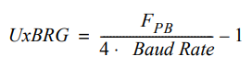

Equation 5.2. UART Baud Rate Generator

For example, for a desired baud rate of 115200, with FPB being the Peripheral Clock at 40MHz, the BRG value to be loaded into the baud rate register should be 21.

The GPS module uses a special protocol called MTK NMEA Packet Protocol, and is explained in the datasheet for the GPS module:

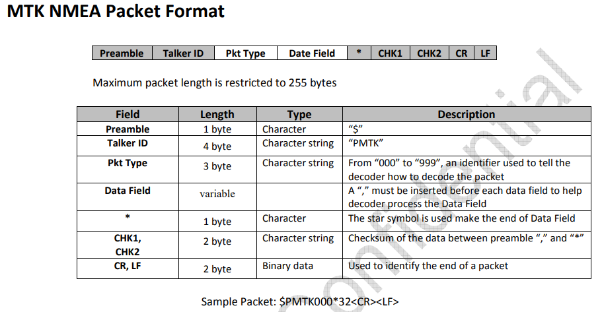

Fig. 5.13. GPS Module NMEA Packet Protocol

Essentially, as the datasheet shows, the packet length consists of a 255-byte length packet, where the packet type and data field are used to access certain parts of the GPS module and command the GPS. The main packet types to consider are 001 PMTK_ACK, 010 PMTK_SYS_MSG, 251 PMTK_SET_NMEA_BAUDRATE, and 622 PMTK_Q_LOCUS_DATA. 001 PMTK_ACK in the GPS module indicates that the module acknowledged a command, while 010 PMTK_SYS_MSG outputs a system message whether an operation was successful or not. 251 PMTK_SET_NMEA_BAUDRATE sets the baud rate of the GPS module, and 622 PMTK_Q_LOCUS_DATA dumps all stored data.

The following is a sample flowchart of how a standard run with the PIC32 and GPS goes:

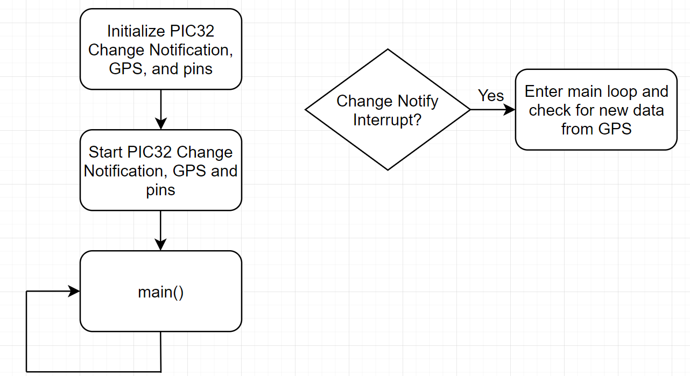

Fig. 5.14. Sample Run with the PIC32 and GPS

In the initialization phase, the Change Notification module is configured with the desired pins to keep track of, and the pin itself is configured as an input, and is given a starting value of 0. The GPS is also initialized to its max sample rate and a baud rate of 115200. The Change Notification module and GPS are then turned on, and the program enters the main loop. The main program waits until the GPS has a fix by waiting until a flag is set by the Change Notification interrupt, and then in the main loop, if the GPS has new data, it will be read from by using the packet protocol described earlier.

The corresponding pinouts for the MTK3339 GPS Module is shown in figure 5.15 below.

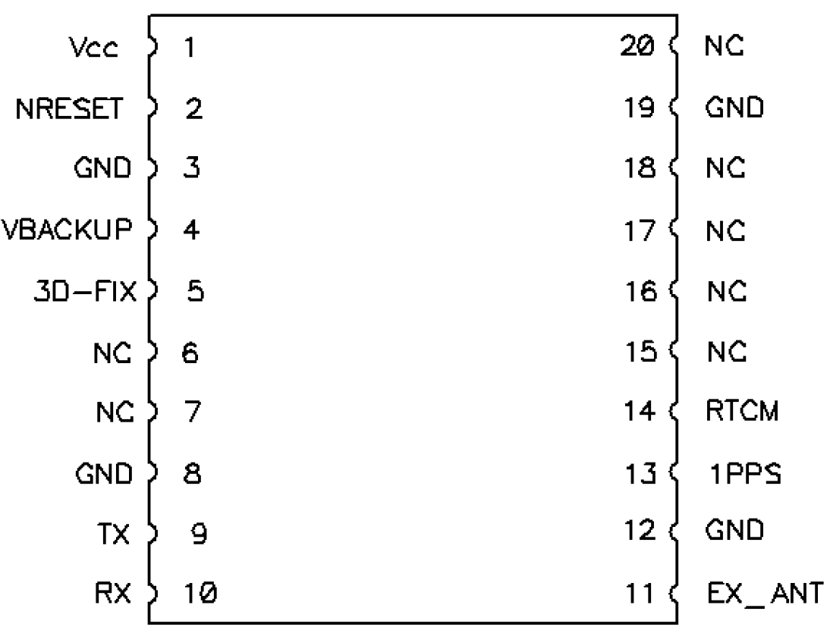

Fig. 5.15. Top Down Pinout Diagram of MTK3339 Module

The MT3339 GPS Module takes 3.3V from the 3.3V plane from the PCB into VCC/pin1. The NRESET/pin is not connected since the module is not needed to be reset during flight, not the NRESET pin is active low so do not ground the pin when in use. The VBACKUP pin is connected the positive terminal of a CR1220 coin battery holder on the PCB board. The 3V power to VBACKUP keeps the internal real time clock of the GPS module running when there is no power to VCC/pin1. The 3D-FIX/pin5 is connected to RF6/pin 35 of the PIC32 microcontroller. A 1Hz pulse indicates the GPS module is seeking a lock on a GPS and a logic low indicates at least 1 satellite lock is acquired, which is needed on startup of the drone to show if the GPS is capable of autonomous flight. Pins 6,7,15,16,17,18 are not connected to any traces on the PCB but are soldered in place. The ground pins 8, 12, and 19 are connected to the ground plane of the PCB using a via hole. TX/pin 9 is connected to U1RX/pin 34 of the PIC32 microcontroller and RX/pin 10 is connected to U1TX/pin 33 of the microcontroller for sending coordinate packets and other debug packets via UART protocol. [24]

5.1.5 MPRLS0001PG00001C Balloon Pressure Sensor

The MPRL balloon pressure sensor satisfies STR 4.3.3. By having a tube attached from the nozzle of the balloon to the gauge reference hole, the sensor shall detect a decrease in pressure and send an error message via I2C to the PIC32 microcontroller.

The MPR balloon pressure sensor is powered by 3.3V from the PCB 3.3V power plane to VDD/pin 12 and also has a 0.1uF bypass capacitor soldered on the PCB for voltage noise suppression[25].

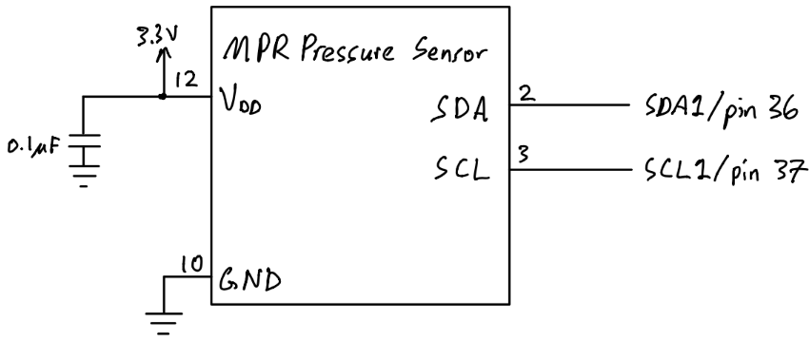

Fig. 5.16. MPR Pressure Sensor Pinout Diagram

GND/pin 10 is connected to the ground plane of the PCB through a via pin. SDA/pin 2 of the pressure sensor is connected to SDA1/pin 36 of PIC32 microcontroller for data line of I2C and SCL/pin 3 is connected to SCL1/pin 37 of the microcontroller for the clock of I2C. Pressure data is polled via pin 2 and pin 3 of the pressure sensor instead of interrupt driven since there are no interrupt pins available on the sensor IC itself.

5.1.6 Microcontroller Selection

Once the proper sensors and remote controller receiver, servos, and motors were chosen, the microcontroller could be chosen. These are the hardware requirements that were needed for the microcontroller:

* Raspberry Pi - 1 unique SPI
* Ultrasonic sensor - 1 unique Input Capture module
* IMU sensor - 1 shared I2C module and 1 unique Change Notification module
* Altimeter - 1 shared I2C module and 1 unique Change Notification module
* GPS - 1 unique UART module and 1 unique Change Notification module
* Remote controller receiver - 4 unique Input Capture modules
* Servos - 2 Output Compares
* ESC/Motors - 2 Output Compares

In total, the microcontroller needed to have 1 SPI, 1 I2C, 3 Change Notification, 1 UART, 5 Input Capture, and 4 Output Compare modules. For this reason, the PIC32MX340F512H was chosen as the microcontroller for having the following hardware specifications:

* 2 SPI modules
* 2 I2C modules
* 2 UART modules
* 5 Input Capture modules
* 5 Output Compare modules
* 17 Change Notification modules

In addition, the PIC32MX340F512H was compatible with the MPLAB X IDE, which allowed for easy access to low level hardware.

5.1.7 Microprocessor Selection

For the microprocessor, there were only a few requirements that were needed of it:

* PIC32MX340F512H - 1 unique SPI module
* Data Telemetry Transmitter - 1 unique UART module

In total the hardware requirements the microprocessor needed were 1 SPI and 1 UART module, so a Raspberry Pi Compute Module 3+ was chosen, as it had the following hardware:

* 2 SPI modules
* 2 UART modules

5.1.8 Sensor and Microcontroller Verification

In order to verify the ultrasonic, altimeter, IMU, and GPS sensors performed to their requirements, all sensors were logged at the same time over a period of time, and had their precision determined by using the actual known values the sensors were measuring against, and comparing it to the measured values. The setup with all the sensors looked like the following:

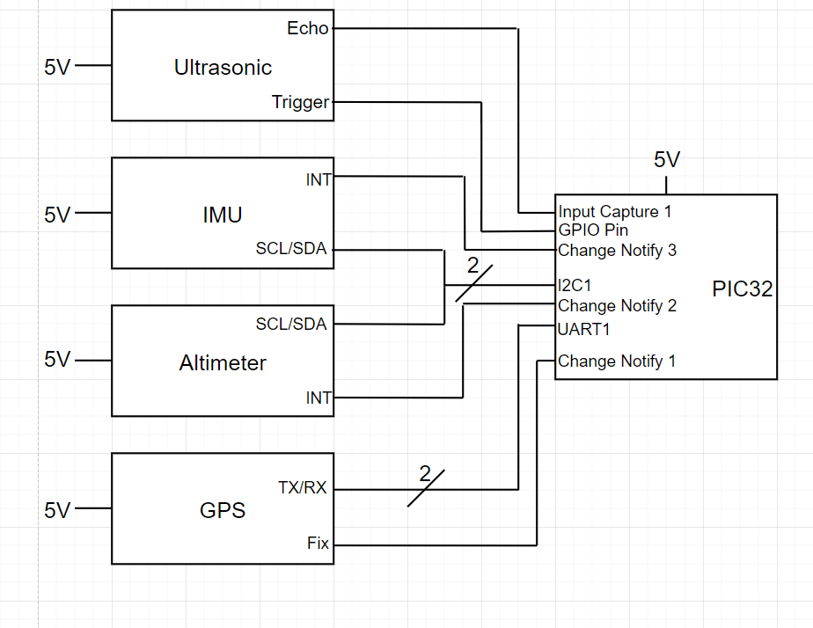

Fig. 5.17. Wiring Diagram of PIC32 with Ultrasonic, IMU, Altimeter, and GPS

Once the sensors were set up, measurements were taken from each of the sensors and compared with their expected values:

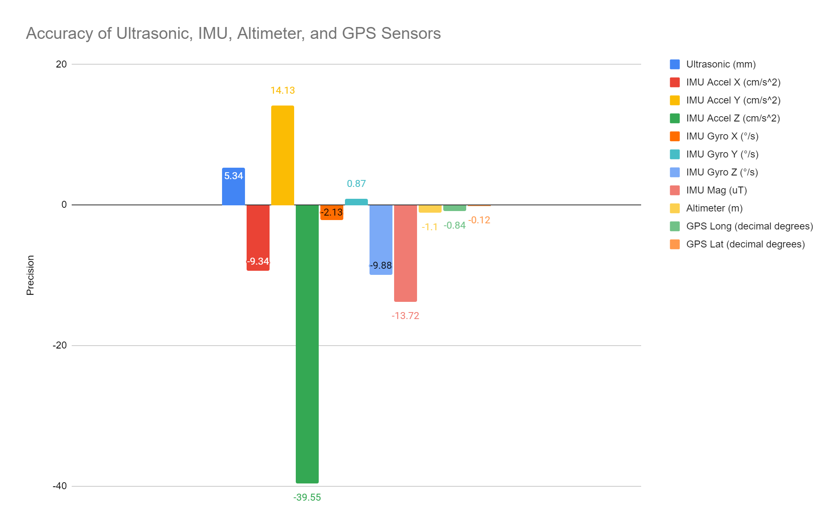

Fig. 5.18. Graph of Accuracy of Ultrasonic, IMU, Altimeter, and GPS

As the graph shows, the ultrasonic was within 5mm accuracy, the IMU acceleration along X, Y, Z axes was around 9, 39, and 2 cm/s2 precision respectively, the IMU rotational speed along X, Y, Z axes was around 2, 1, and 10 degrees/s precision respectively, the IMU magnetic field magnitude was around 14 uT accuracy, the altimeter was around 1m accuracy, and the GPS longitude and latitude values were around 1 and 0 decimal degrees respectively. With the requirements for the ultrasonic to be within 15cm accuracy, IMU to detect orientation of the drone, the altimeter to be within 1m accuracy, and the GPS to be within 5m accuracy, every sensor but the GPS met system requirements, as it was almost 111 km off. This is believed to be caused by error in coding, and further deliberation with the GPS’s datasheet must be done. In regards to the PIC32 microcontroller, it had the required hardware needed to run all sensors, and is also verified to work correctly with the remote controller receiver, servos, and motors in Section 4.2. To satisfy STR 3.1.2, where the system shall be able to handle user control inputs and error handling.

## 5.2 State Estimation

The state of the drone can never be fully known or directly measured, so functions need to be implemented to estimate all states that are necessary to the drone control system. The states needed for the Closed-Loop RC system will be height, pitch and roll, as well as their derivatives, as described in section 6.7.2

5.2.1 Complementary Filter for Pitch and Roll

Pitch and roll estimation is vital to ensuring the drone maintains stability during flight. The IMU has both accelerometers and gyroscopes and can be used to estimate the drone’s pitch and roll. The gyroscopes are very accurate in the short term, but error and biases add up over time so just integrating the gyroscope values will be an inaccurate estimation of angles. The accelerometers are very accurate in the long term since acceleration over time is 9.8m/s/s downwards, but in the short term, the drone accelerates constantly and is inaccurate. Using a complementary filter, a high gain can be applied to gyroscopic data to take advantage of its high frequency accuracy, and the accelerometers can be given a low gain to take advantage of the low frequency accuracy of the sensor and correct for low frequency gyroscopic error. The complementary filter design in simulink is shown in Fig 5.19.

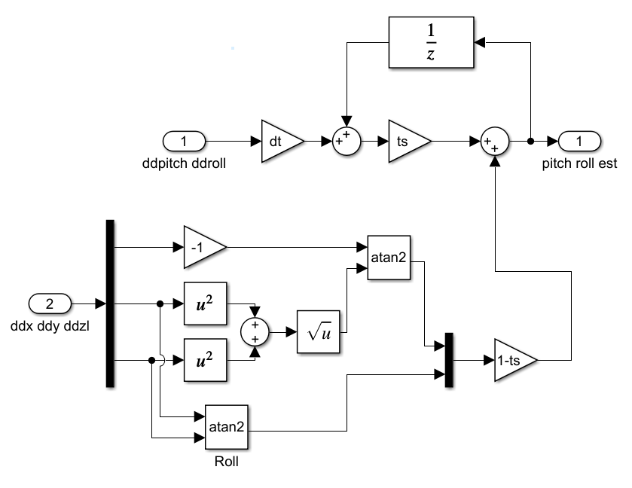

Fig. 5.19. Complementary Filter

The system takes in the accelerometer data in the bottom path and gyrospic data in the top path to be interpreted. dt is the time step of the system, and ts in the ratio of the gryropic data, and ts would be adjusted to get the most accurate pitch and roll state estimations. The system was meant to be tested and tuned in VREP, but since simulation was not complete, the design was not tested.

5.2.2 Terrain Tracking

Terrain tracking is one of the most important features of the drone since the function would allow the drone to be close to the ground without crashing and improve sensor accuracy.

The data of the ultrasonic sensor can be used to calculate the height fairly easily by just translating distance into height, but this does not cover the full area underneath the drone as seen in Fig. 5.20.

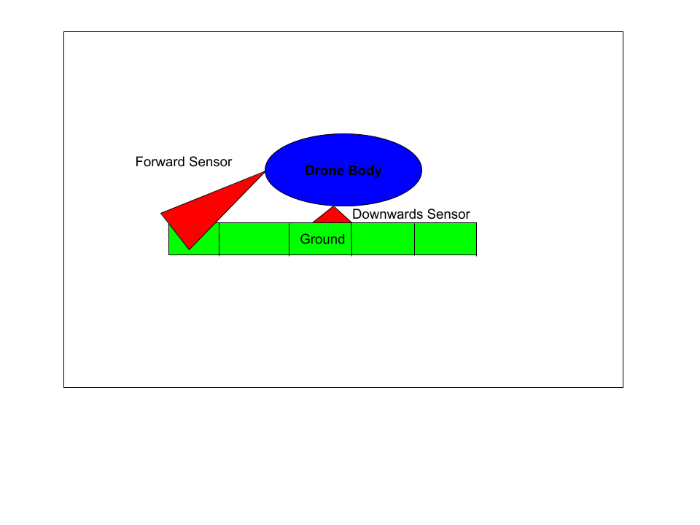

Fig. 5.20. Terrain Tracking Setup

To get a more accurate picture, two approaches were planned but not fully designed. The first, is to break the segment underneath the drone several blocks of a set distance, and measure the nearest ground value and record it as height. The drone accelerometer would be needed to estimate when the drone moves past this block and to the next block, where only the highest value will be recorded for that segment. Then, when the last block is passed behind the drone, the values can all be shifted over one space in memory, so the drone can keep track of the height underneath the drone, even if the ultrasonic is not covering the whole area. The values of blocks that are not being populated with current ultrasonic data would also need accelerometer data to adjust the measured height measurements, but the shift is equal for all blocks. This method enables the drone to keep track of important parts of data, but it isn't required to store every single recorded value, since that would take a lot of memory and slow down the system. To help reject disturbance, a boxcar average could be used to help reject noise or random errors while data is being recorded in every block. The size of the boxcar average would be determined by memory and sample rate, where as the distance chunks storing height values can be chosen as determine to be best during simulation, but even an arbitrary start of 1 m lengths will most likely be ok, and the lengths can be decreased of memory and computational ability is available. Once again, the system was not implemented, but is something that will be worth pursuing in future work on the project.

5.2.3 Other State Estimation

The estimation for the position of the drone and yaw angle using gps, accelerometer, and gyroscopic data was not completed since the autonomous system was not developed.

## 5.3 PCB Interface

5.3.1 Trace Width Calculation

The board house used to manufacture the PCB is OSH Park’s 4 layer PCB manufacturing process. They recommend using 4pcb.com trace width calculator to determine rough minimum trace width of the PCB. The formula 4pcb uses is shown below in equation 5.1.

 (5.3)

Where k = 0.024, b = 0.44, and c = 0.725 for internal layers of the IPC-2221 standard of PCB. For the external layer, k = 0.048, b = 0.44, c = 0.725[26]. These constants are results from curve fitting to the IPC-2221 curves in figure 5.21[27]. I is the current through the trace, T is the max temperature in celsius of the trace and thickness is the depth in oz of the copper trace. The resulting value of the width is in mils (1/1000 of an inch).

The curve in figure 5.21 shows the graph of current vs. trace width of the top and bottom layer of a IPC-2221 board with temperature curves ranging from 10°C to 100°C. Whereas, the curve in figure 5.22 shows the graph of current vs. trace width of the middle two 3.3V and GND layer ranging from 10°C to 45°C. The k, b, c constants from 4pcb are fitted to curves such as figure 5.20 and 5.21 to obtain their values. The curve came from UltraCAD’s own experimentation and testing and is not done by the IPC organization, which is why trace widths are always recommended to be greater than calculated trace width.

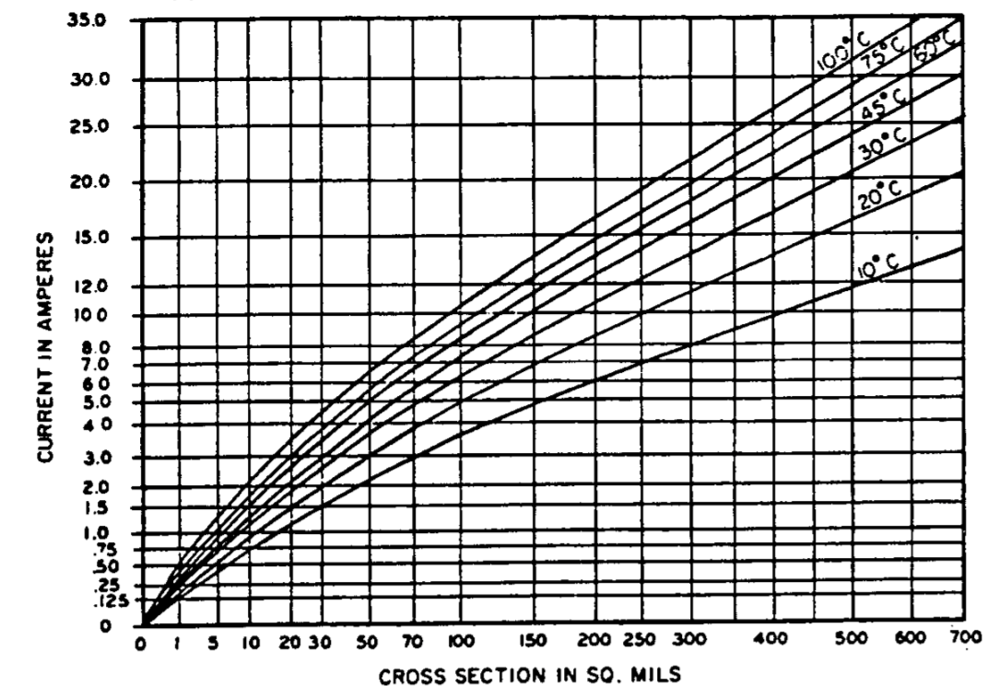

Fig. 5.21. External Conduction

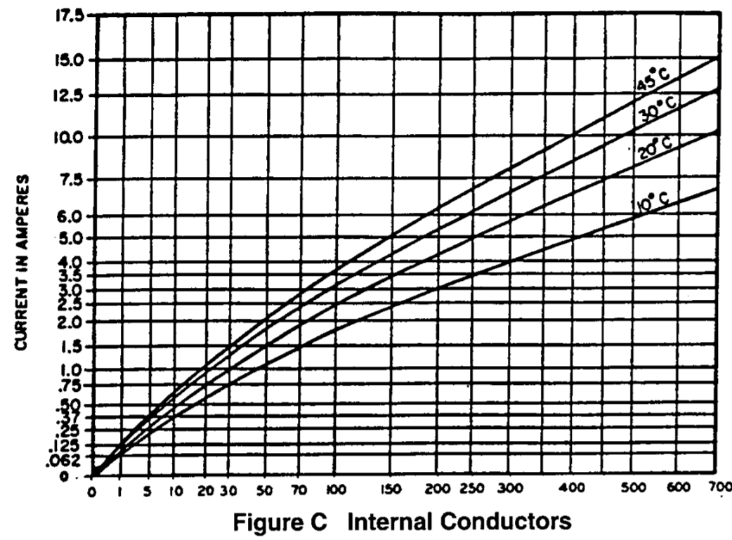

Fig. 5.22. Internal Conduction (X-Axis: Cross Section in Mils)

The 4 layer board from OSH Park has 1oz copper traces on both top and bottom and 0.5oz copper traces in the middle two layers of the PCB. The traces used by the drone are wider in width than the width the formula calculates.

Table 5.23

Calculated Trace Width Given Voltage, Current and Thickness

| Voltage[V] | Current[A] | Thickness[oz/ $ft^{2}$] | Width[mils] | Actual Width[mil] |
| --- | --- | --- | --- | --- |
| 12 | 14.949 | 1 | 224 | 250 |
| 5 | 0.59 | 1 | 2.59 | 16 |
| 3.3 | 0.534 | 0.5 | 11.7 | 16 |
| 1.8 | 0.268 | 1 | 0.872 | 16 |

3.3V has 0.5 copper thickness due to board manufacturing specifications for internal layers. 3.3V is chosen to be the power plane of the PCB because most of our sensor array uses 3.3V such as the MPL3115A2 altimeter, MT3339 GPS module, and MPRL balloon pressure sensor. 12V, 5V, and 1.8V rails are run on both top and bottom layers, which have 1 oz thickness. 300mil traces on both top and bottom are used to connect between the 12V battery to ESC pinouts as shown in figure 5.24.

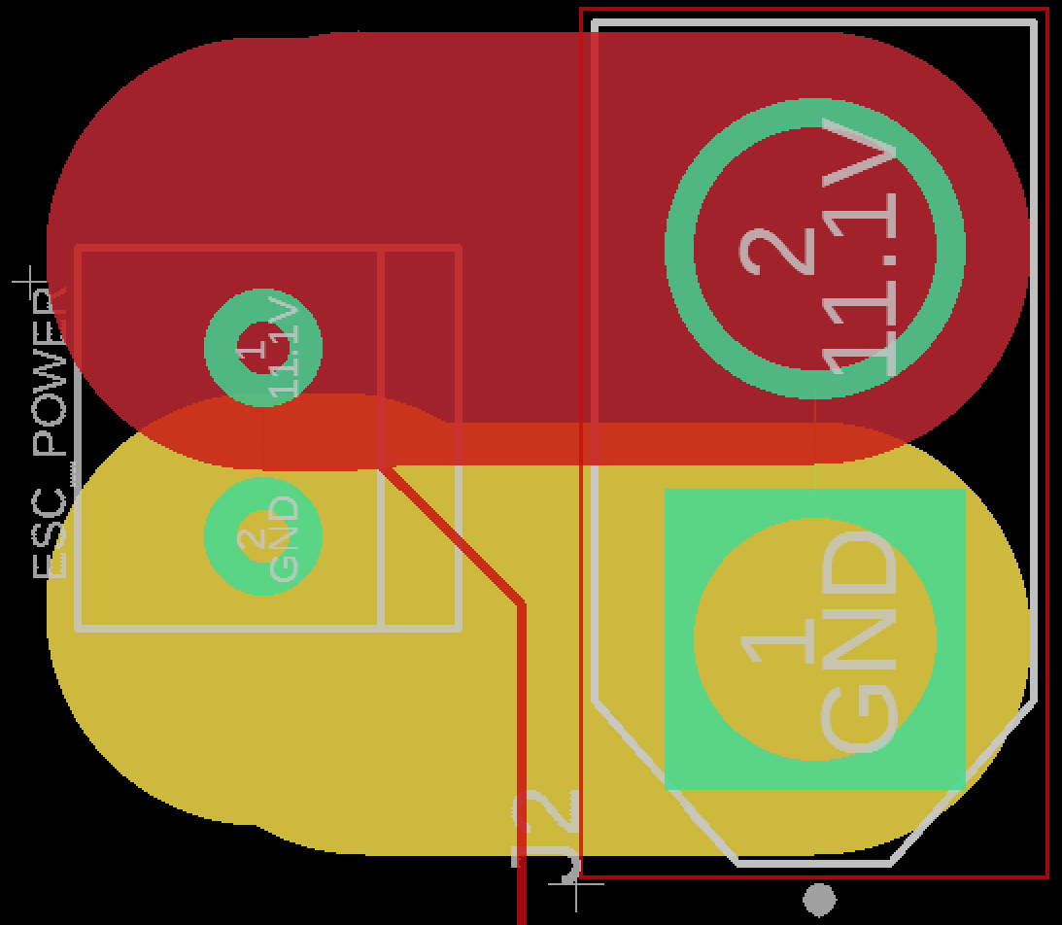

Fig. 5.24. Trace Between 12V Battery Pinout (right) to ESC Pinout (left)

This is to ensure the required current by ESC is supplied through the traces without heating or burning up the traces which could prove detrimental to the PCB board and would require a new board to be installed. OSH Park requires a minimum trace width of 5 mils, and using the formula as a guideline, 16 mils are used for 5V, 3.3V, and 1.8V voltage regulators to ensure no traces are too thin to be burnt up. Also, due to having only one 1.8V voltage regulator and having the Raspberry Pi microprocessor and IMU needing 1.8V for power at opposite ends of the PCB, longer traces are needed to reach those components, so a wider trace width prevents risk of having high resistance in the power lines. Too large of a trace width will reduce top plane surface area for IC pads and overall separation of power and signal traces.

5.3.2 Board Manufacturer Design Rule Check

OSH Park has a downloadable DRC file that users can download for EagleCAD board design. This automatically sets the minimum required distance between via holes to pads, minimum amount of copper added around plated through-holes for soldering or via holes, and copper and core thickness relative to each other.

5.3.3 PCB 4-Layer Stackup

Figure 5.25 shows a helpful guide of layer-by-layer of thicknesses for silkscreen for text on the board, solder resist for top and bottom to repel solder on unwanted surface of the boards, 1oz and 0.5oz copper, and prereg/core of the board that separates the four copper planes from each other.

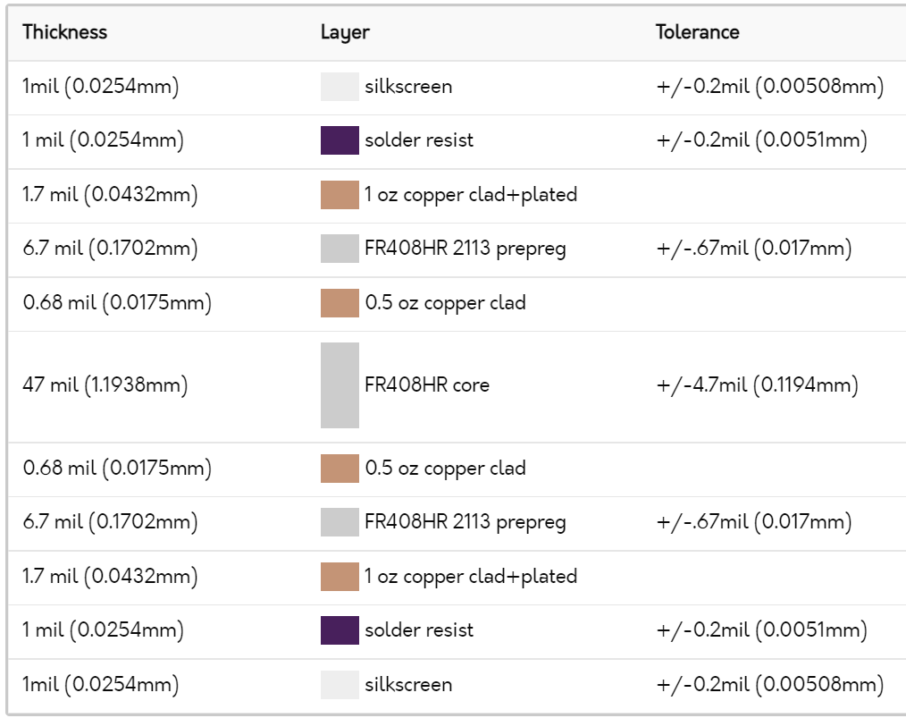

Fig. 5.25. 4-Layer Stackup of OSH Park Board

Once the 4 layer DRC file has been downloaded and loaded onto EagleCAD under DRC>File, the layer pairs under DRC>Layers should show tolerated thicknesses of the copper and core material as shown in figure 5.26 below.

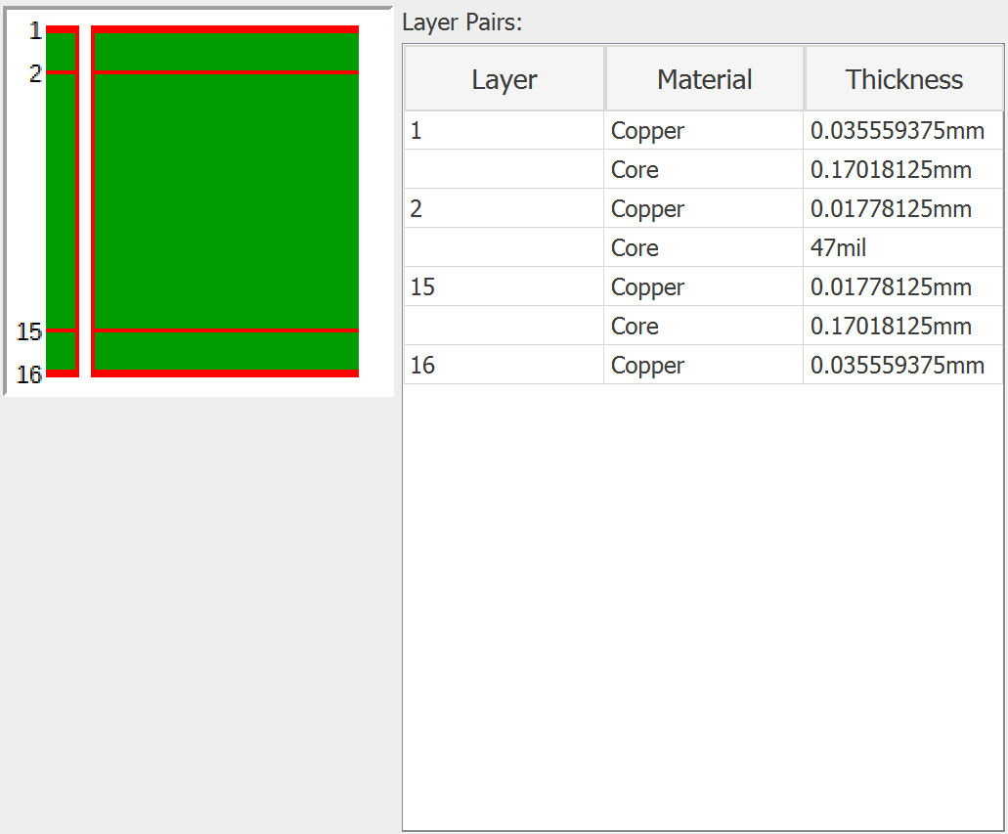

Fig. 5.26. EagleCAD 4-Stack Layer Thicknesses DRC Setting

5.3.4 Oscillator Placement

The primary 8MHz oscillator labeled X1 as shown in figure 5.27, and secondary 32.687kHz oscillator labeled Y1 in figure 5.28 below are placed no more than 1 inches away from the PIC32 microcontroller’s pads on the left.

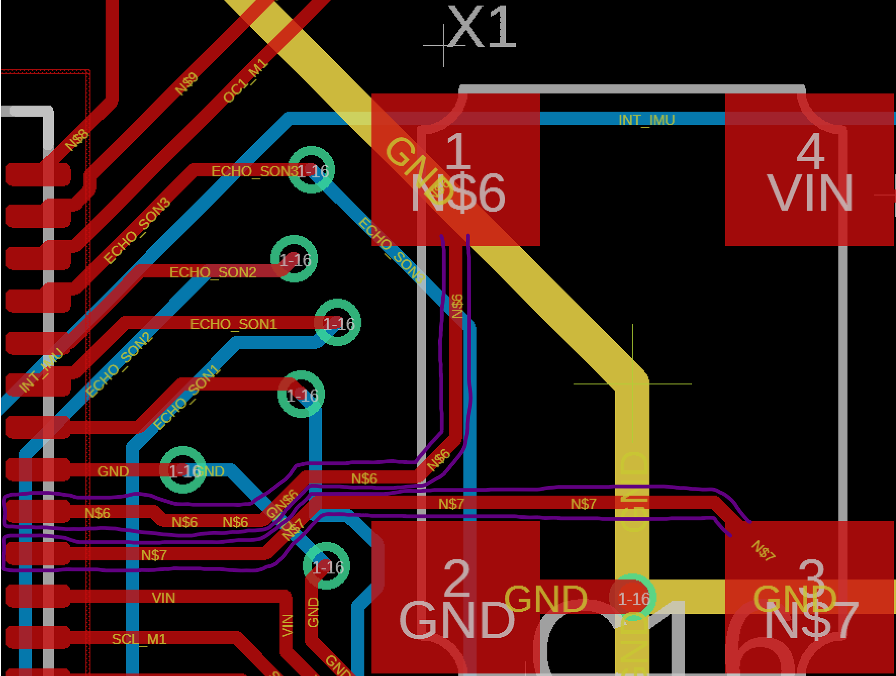

Fig. 5.27. 8MHz Oscillator Traces on the Right Leading to PIC32 Microcontroller Pads on the Left (circled in purple)

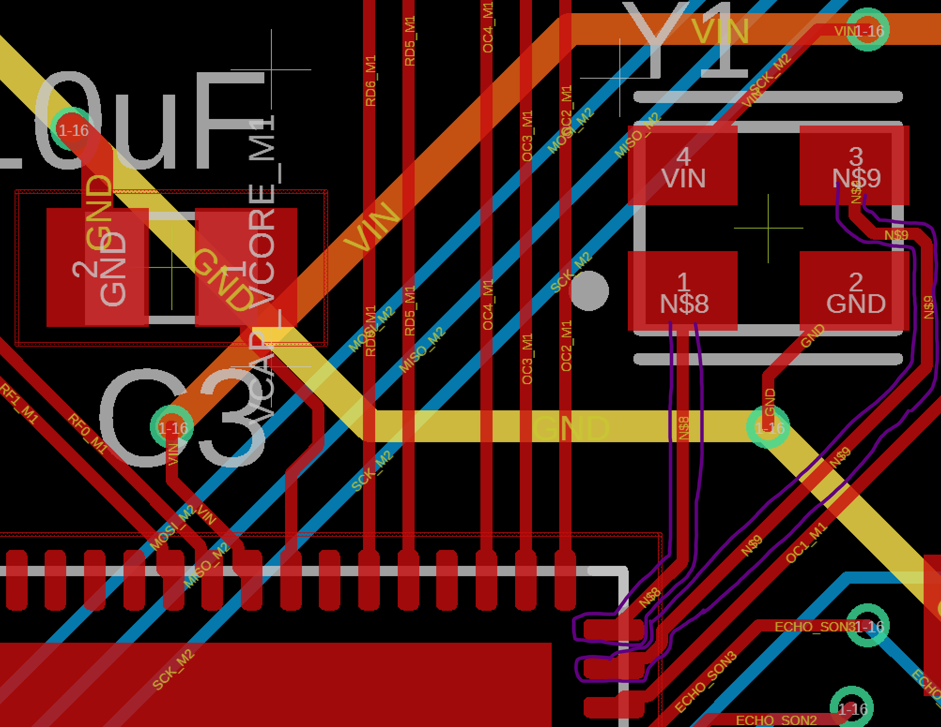

Fig. 5.28. 32.768kHz Oscillator Traces on the Top Right Leading to PIC32 Microcontroller Pads on the Bottom Left (Circled in Purple)

The 8MHz and 32.768kHz crystal oscillators are considered to produce the most noise out of any other components, so it should be placed as close to the microcontroller as possible to reduce trace length as much as possible. In Henry Ott’s Electromagnetic Compatibility Engineering textbook section 16.1.4 [28], it is important to keep clock traces as short as possible as they emit the most EMI even though they make up less than 10% footprint of the board. The 8MHz was placed as close to the PIC32 microcontroller as first consideration to have minimal trace length before sensor IC footprints were placed to reduce EMF as much as possible and also to satisfy STR 6.0.0 (magnetometer interference shall be less than 10nT).

5.3.5 4-layer Board Stackup

A 4 in by 4 in PCB board was designed as the only real constraints of the board were gondola size which needed to house the PCB board underneath the balloon and also benefits to cutting down weight by having a small PCB board with an overall surface area of 16 $in^{2}$ (not including the bottom signal layer of the PCB). A 4-layer stackup was chosen over the 2-layer stackup to allow for densely packed IC’s that included microcontrollers, microprocessors, IMU, GPS module with surface mount U.FL coax antenna, two pressure sensors, and logic converters. Pinouts for ultrasonic sensors, high current battery, switching regulators, and transmitters and receivers also fit within the 4 in by 4 in footprint.

Under section 16.4.2.2 Four-Layer Boards of Henry Ott’s ECE textbook[29], 4 layer boards improve electromagnetic compatibility and signal integrity of the sensor array and clocks of the oscillators by having a 0.0067 inch spacing between the top signal and ground layers. 4 layer stackup also reduces ground plane impedance because the ground plane is closer to the signal layer, whereas a 2 layer stackup does not have a ground plane at all, benefiting STR 6.0.0 to working towards a magnetic interference less than 10nT. By having an improved 4 layer board layer spacing as shown in figure 5.29 below compared to figure 5.30.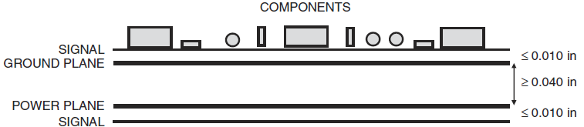

Fig. 5.29. Improved 4 Layer Board Configuration

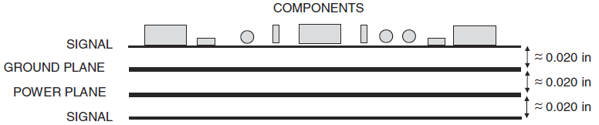

Fig. 5.30. Equally Spaced 4 Layer Board Configuration

OSH Park produces boards that satisfy figure 5.29 specifications as shown in figure 5.25, with the two inner planes separated by 0.047 in, satisfying the ≥ 0.04 in in figure 5.29, and by having the ground plane and signal plane closer results in a ground plane inductance of 0.085nH/in (shown in figure 5.30) compared to 0.13nH/in for a equally spaced 4 layer board in figure 5.29, also reducing ground noise by 35%.

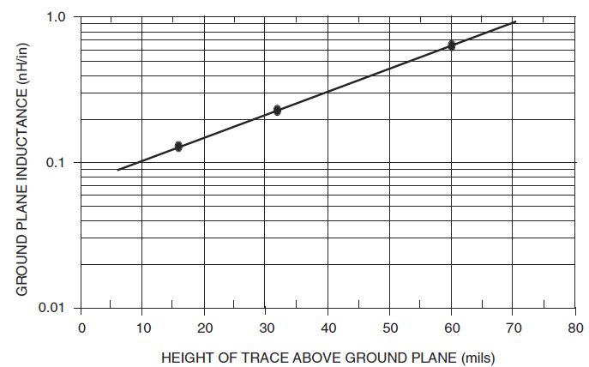

Fig. 5.31. Ground Plane Inductance vs. Trace Height

Having a 4 layer board allows for ground and power traces to be moved into the inner two planes, with the ground plane closest to the top traces and power plane closest to the bottom traces. The removal of power and ground traces on the top and bottom layers allows for more room on the signal trace layer to have more IC’s to be soldered and allows for easier traces to be made by a novice engineer. However, the manufacturing time for a 4 layer PCB is considerably longer compared to 2 layer PCB because it requires two processes: the middle two layers to be etched as well as the outer two layers, whereas the 2 layer PCB only requires the top and bottom layers to be etched. As of June 2021, OSH Park board house ships 2 layer PCB within 4-5 days, whereas 4 layer PCB can only ship as fast as 9-14 days. This is why it is critical to follow strict PCB design guidelines before sending it to the boardhouse or else one can risk having a defectively designed PCB shipped and wasting money.

5.3.6 Power and Signal Location

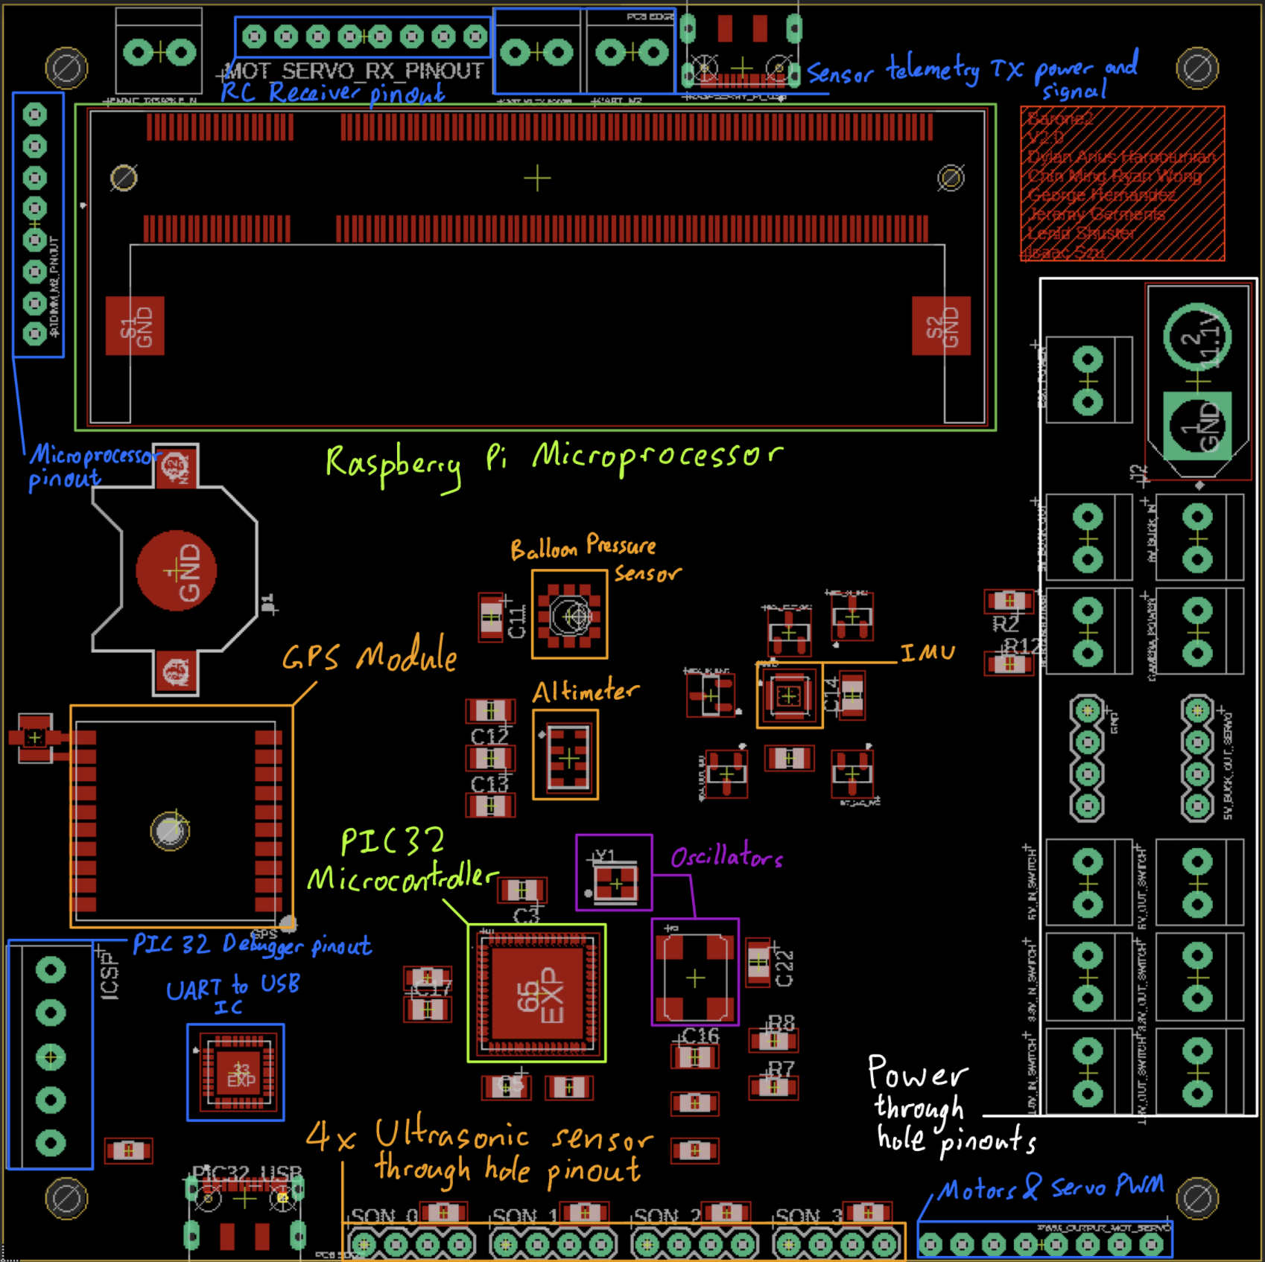

Fig. 5.32. PCB V2.0 Annotated

To reduce EMI of the sensors from power, pinouts for power are located on the right side of the PCB board as shown in figure 5.32. Sensors and microcontroller are placed in the middle to allow microcontroller’s pinout pads to be able to reach the ultrasonic sensor pinouts, IMU, altimeter, balloon pressure sensor, GPS module and Raspberry Pi microprocessor.

All components except the GPS U.FL antenna located left of the GPS module is the only analog signal in the entire board which are digital. That is why the U.FL surface mount antenna is placed furthest from the power rails to reduce as much signal noise as possible. The signal traces for I2C, SPI, trigger and echo pins for sensor array are on the top and bottom layer, while the 3.3V power plane that powers the balloon pressure sensor, oscillators, altimeter, microcontroller and microprocessor is on the inner lower plane. The GND plane is the inner upper plane right below the top layer trace. Having a ground plane right below a low-frequency analog signal allows for a signal return path for the U.FL antenna [30], and high frequency clocks such as the 8MHz and 32.768kHz oscillators in figure 5.32.

Pinouts for all breakout boards/components are located on the side of the PCB to allow for ultrasonic sensor ribbon cables to be wired out through the side of the gondola. The ICSP pinout is located on the left bottom side to be closer to the PIC32 microcontroller as it works to flash the microcontroller, furthermore the signal pads connected to ICSP pinout is located on the left top and bottom side of the PIC32MX340F512H microcontroller, shortening trace length to the pinouts. The UART to USB converter IC is located right above the USB-C hardware port where USBD+ and USBD- signal traces are connected to for shorter trace length. The UART bus from the UART to USB IC then leads to the microcontroller’s second UART pinout. The microprocessor pinouts located top left of figure 5.32 is conveniently located there for shorter trace length from the pinouts to the Raspberry Pi microprocessor in the top center, the same reasoning applies for the RC motor and servo radio RX as its PWM signals are inputted to the Raspberry Pi microprocessor as well.

5.3.7 Power Verification

Upon receiving the PCB V2.0 board, the first verification process is to solder the two 5V switching regulators shown in figure 5.33 below.

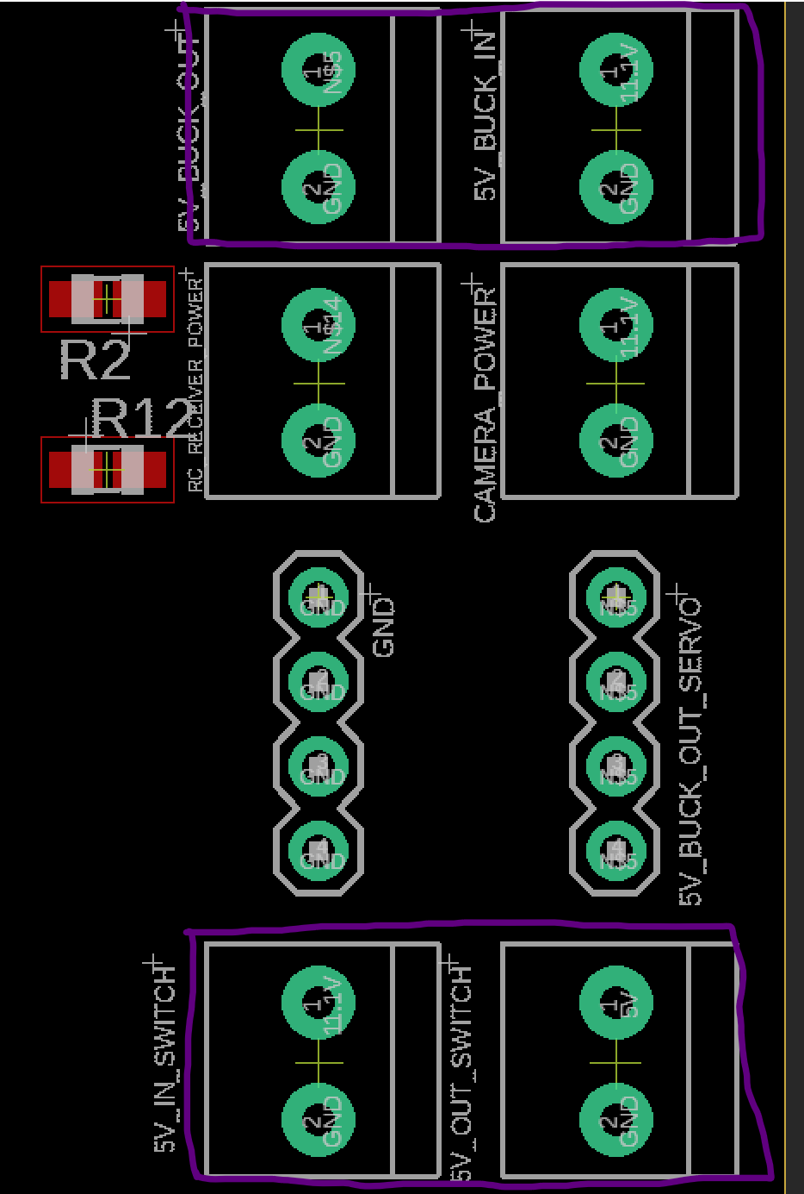

Fig. 5.33. 5V Switching Regulator Pinouts (Boxed in Purple)

Using breadboard wires to solder the power input from the 11.1V rail and ground pin, shown in figure 5.34.

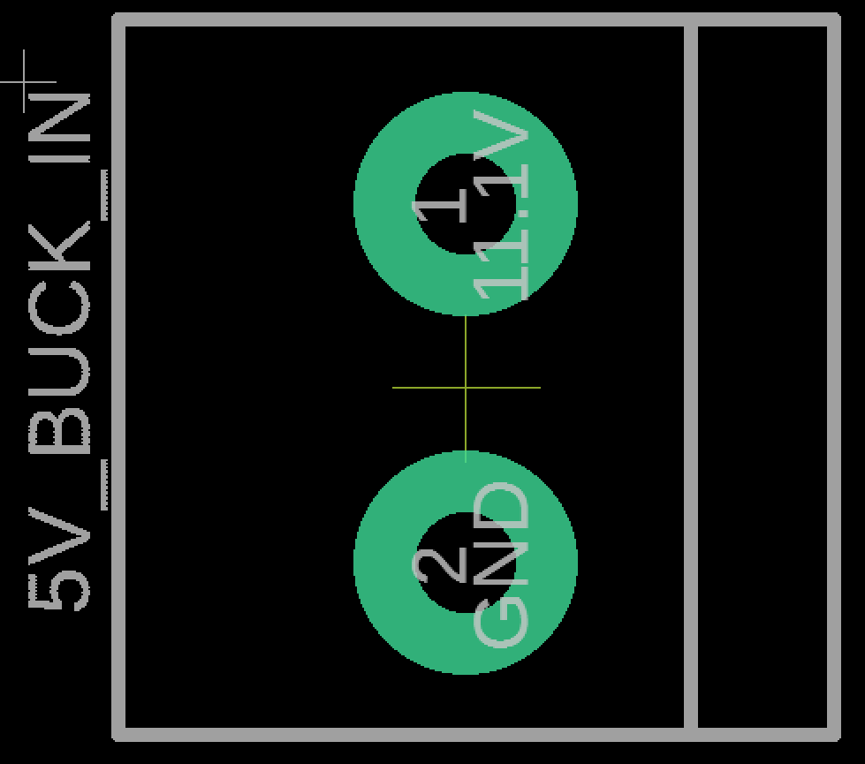

Fig. 5.34. Zoomed in Version of Figure 5.33 Input Voltage from 11.1V

Then solder the through hole pins for the 5V power out from the switching regulator and ground pin as shown in figure 5.35.

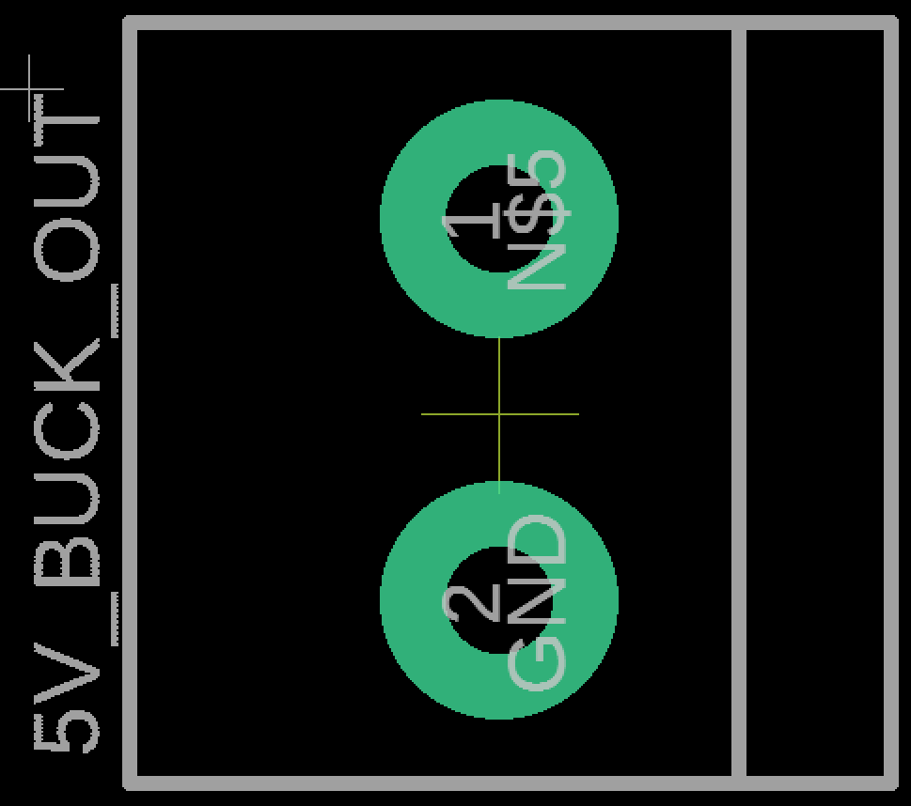

Fig. 5.35. Zoomed in Version of Figure 22 Output Voltage for 5V

To provide power to the 5V switching regulator, solder the XT60 header for the 11.1V battery to the J2 header shown in figure 5.36.

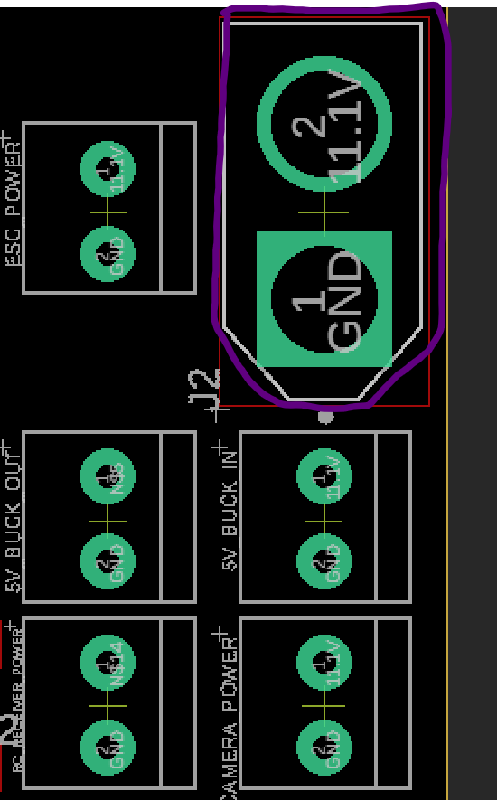

Fig. 5.36. 11.1V XT60 Battery Input Header

To test out the power delivered by the 5V switching regulator, use a voltage meter and probe the following through holes in figure 5.37 with the negative probe on one of the 4 ground pinouts labeled GND left of the servo power.

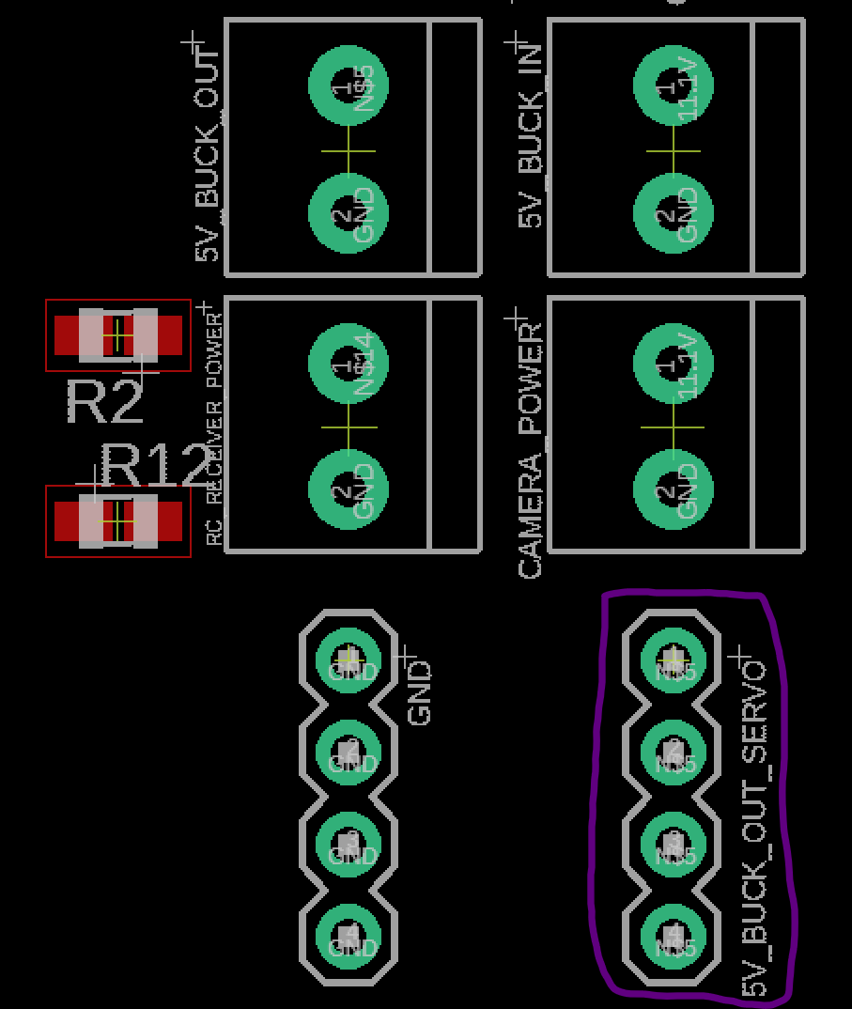

Fig. 5.37. Servo Power Pinout Test Point (Circled in Purple)

The second 5V switching regulator located beneath the servo power pinouts, as shown in figure 5.38, provides 5V power to the ultrasonic sensors and the Raspberry Pi microcontroller.

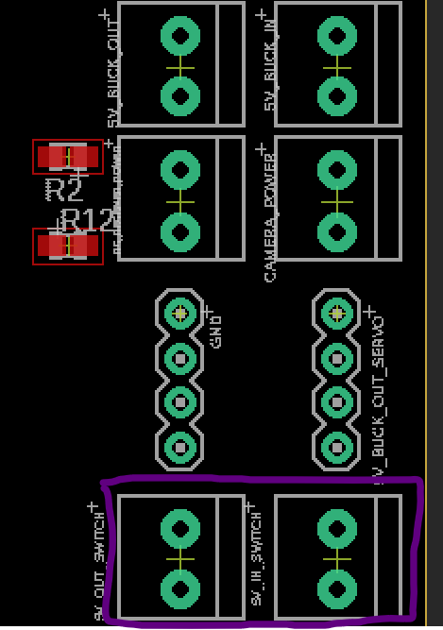

Fig. 5.38. 5V Switching Regulator Pinouts for Raspberry Pi Microprocessor and Ultrasonic Sensor

To verify 5V power coming out of the second switching regulator, use a multimeter to probe the Raspberry Pi CM3+ compute module’s pins 197-200 shown in figure 5.39 below.

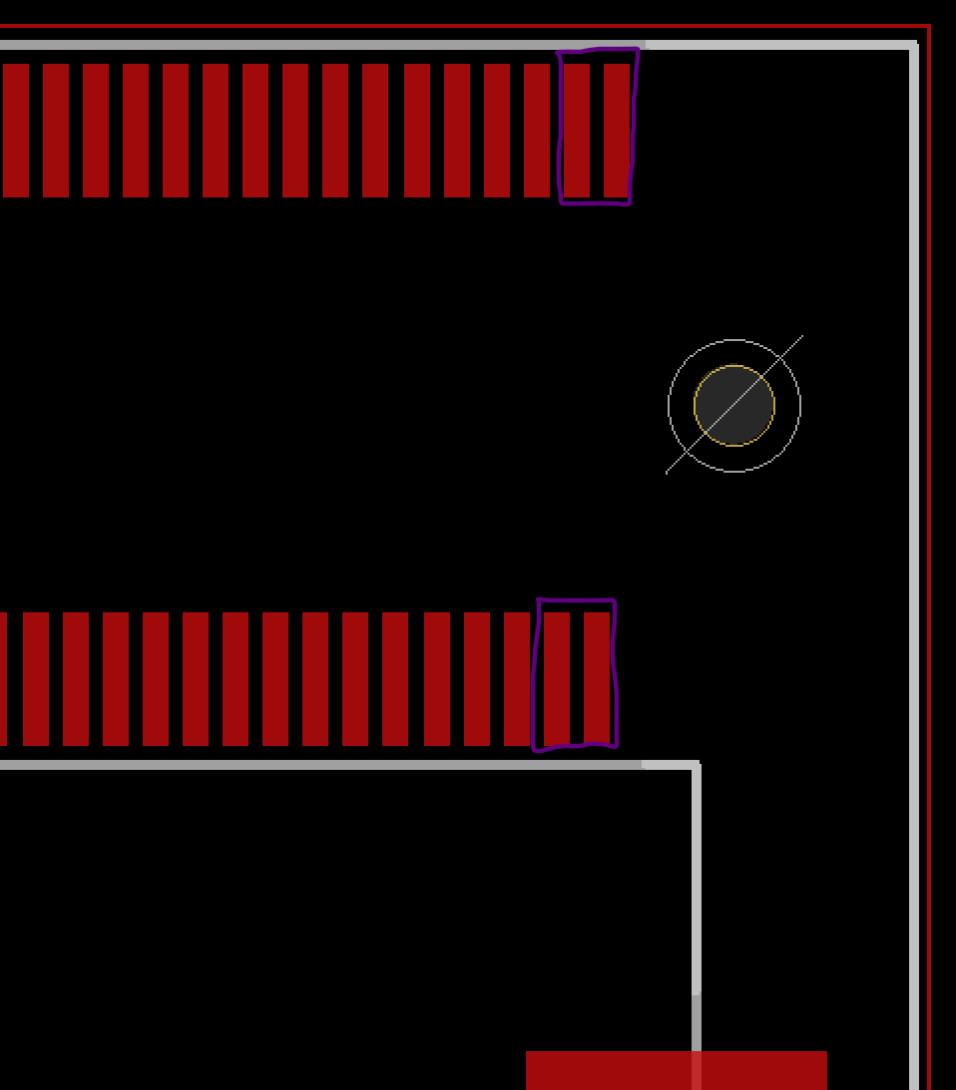

Fig. 5.39. Raspberry Pi Microcontroller 5V Pads (Boxed in Purple)

Verify 5V going into each of the four ultrasonic sensor power pins located on the bottom of the board as shown in figure 5.40 below.

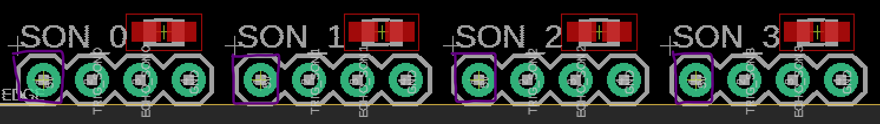

Fig, 5.40. Ultrasonic Sensor 5V Test Points (Boxed in Purple)

Next, solder the 3.3V switching regulators to these locations shown in figure 5.41 below.

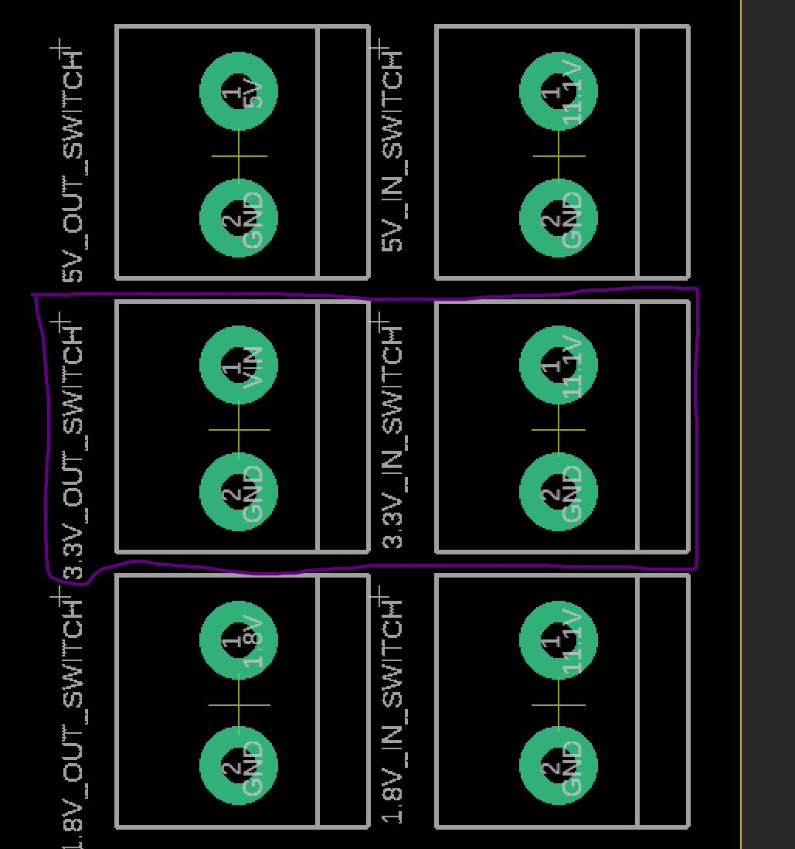

Fig. 5.41. 3.3V Switching Regulator Through Hole Solder Points

Ensure 11.1V battery is plugged into the PCB board and now the power plane of the board should have 3.3V supplying to the altimeter (MPL3115A2 barometric and temperature sensor). Probe the following boxed pads in figure 5.42 below and make sure 3.3V is present on the voltage meter.

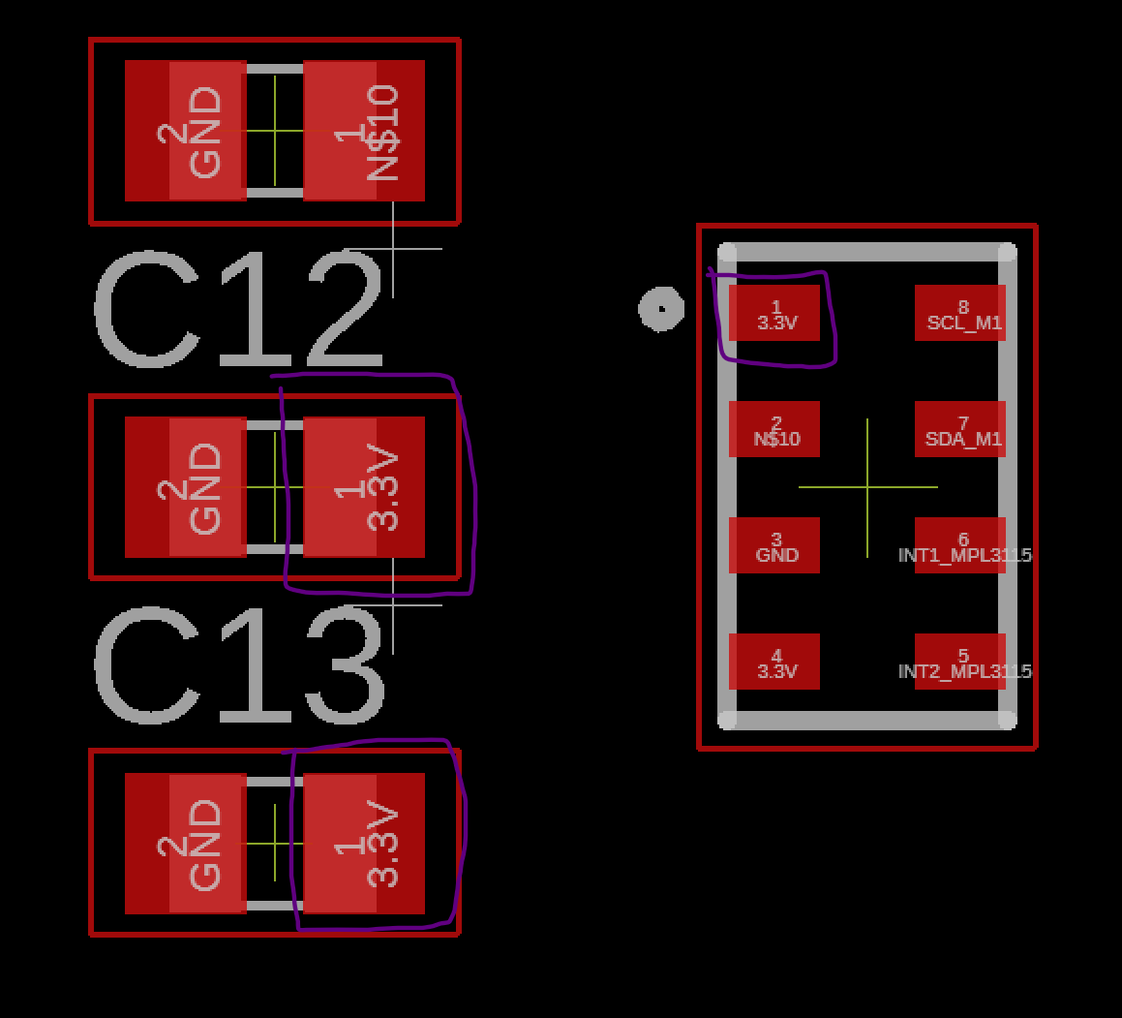

Fig. 5.42. Altimeter Sensor 3.3V Probe Points (Boxed in Purple)

Verify the MPR barometric sensor for the balloon right above the altimeter shown in figure 5.43 below.

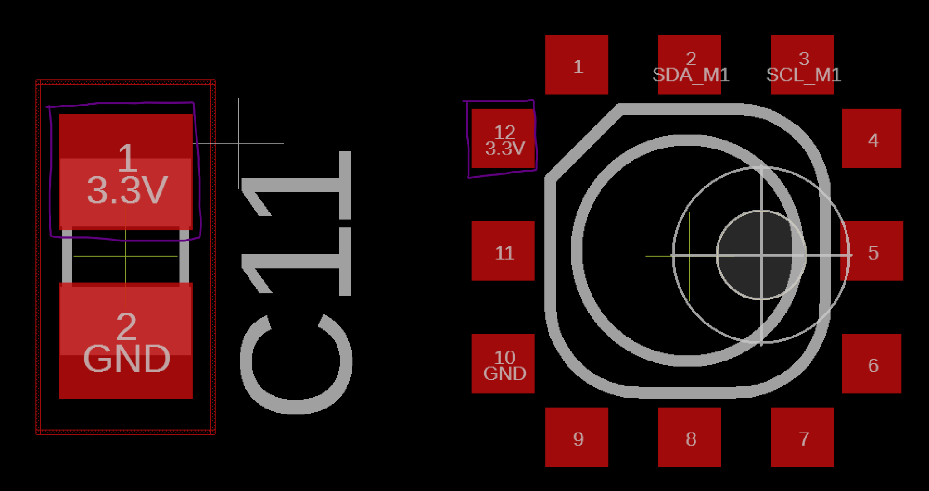

Fig. 5.43. Balloon Pressure Sensor 3.3V Probe Points (Boxed in Purple)

Next, probe the 3.3V for the GPS module Vin located center left of the board as shown in figure 5.44 below.

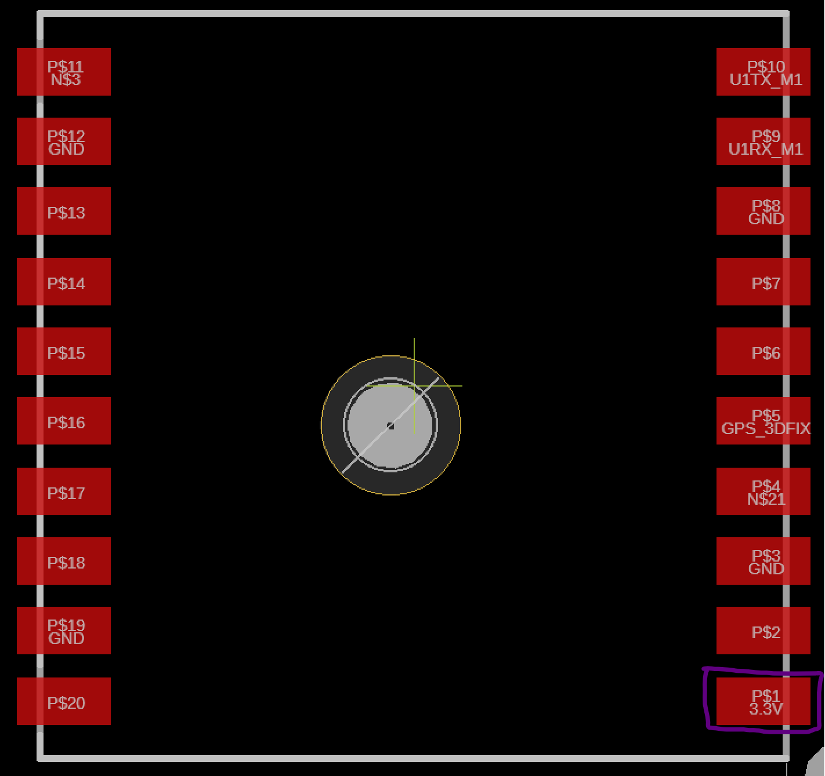

Fig. 5.44. GPS Module 3.3V Probe Points (Boxed in Purple)

Most of the sensor array power input should be verified by now, except for the ultrasonic sensor and IMU. For microcontroller and oscillator power verification, probe the following in figure 5.45, that is the PIC32MX340F512 pins 10, 26, 38, and 57.

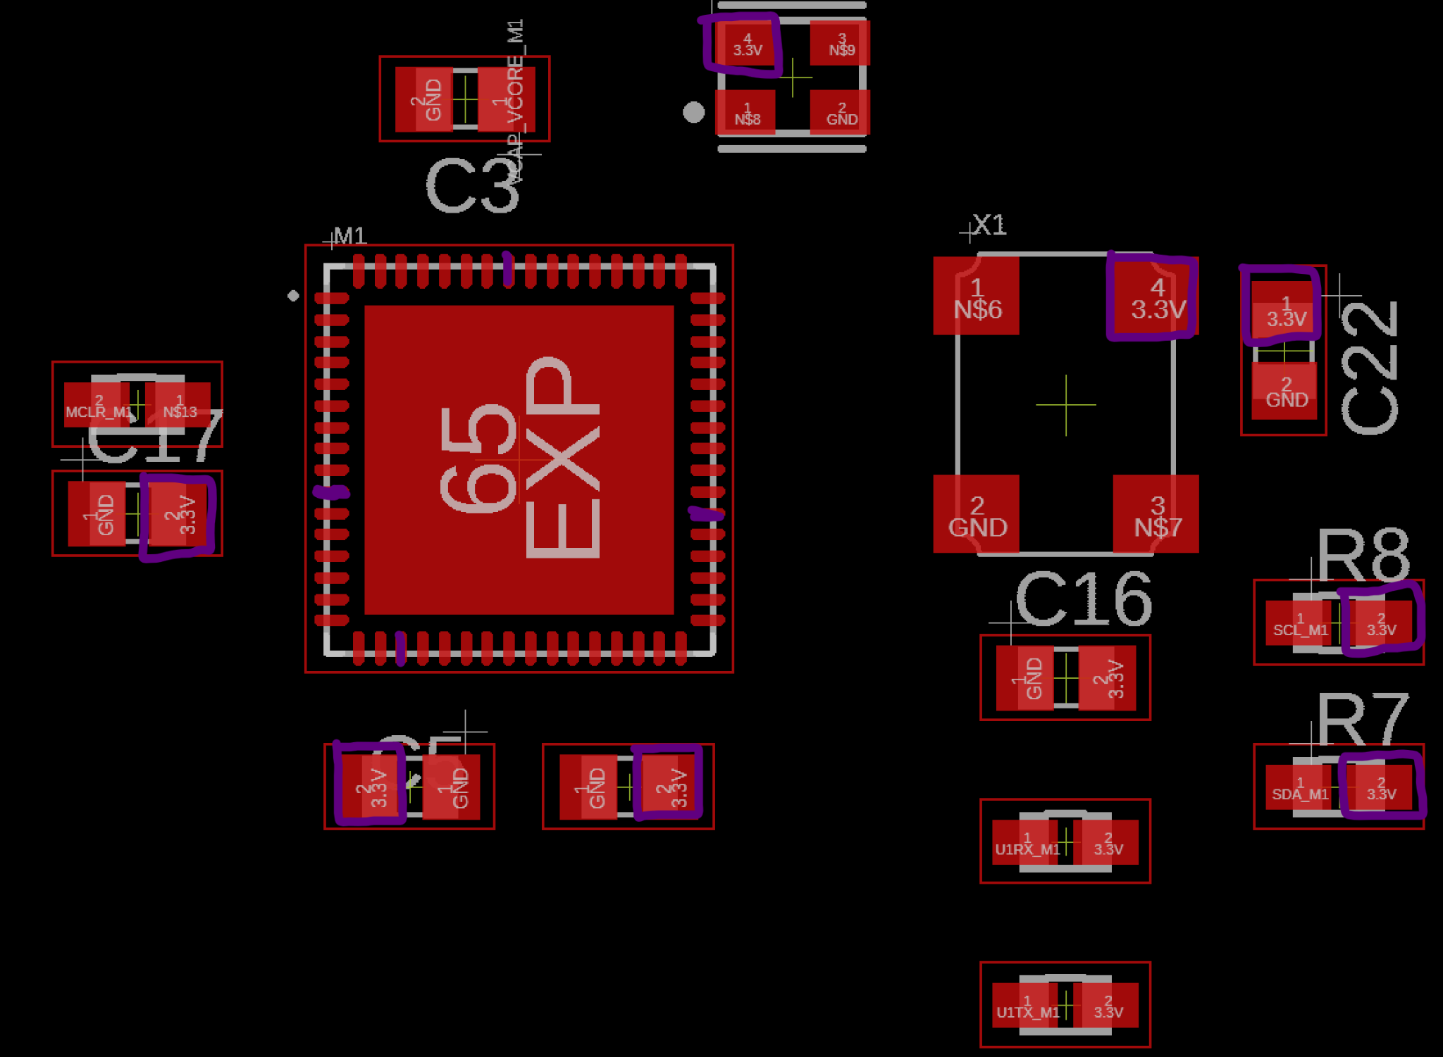

Fig. 5.45. Micrcontroller, Oscillators, and Bypass Capacitors 3.3V Probe Points (Boxed and Colored in Purple)

Next, probe the Raspberry Pi microprocessor pinouts for 3.3V on pins 39, 40, 41, 42, 189, 190, 191, 192, 193, and 194 as shown in figure 5.46 below.

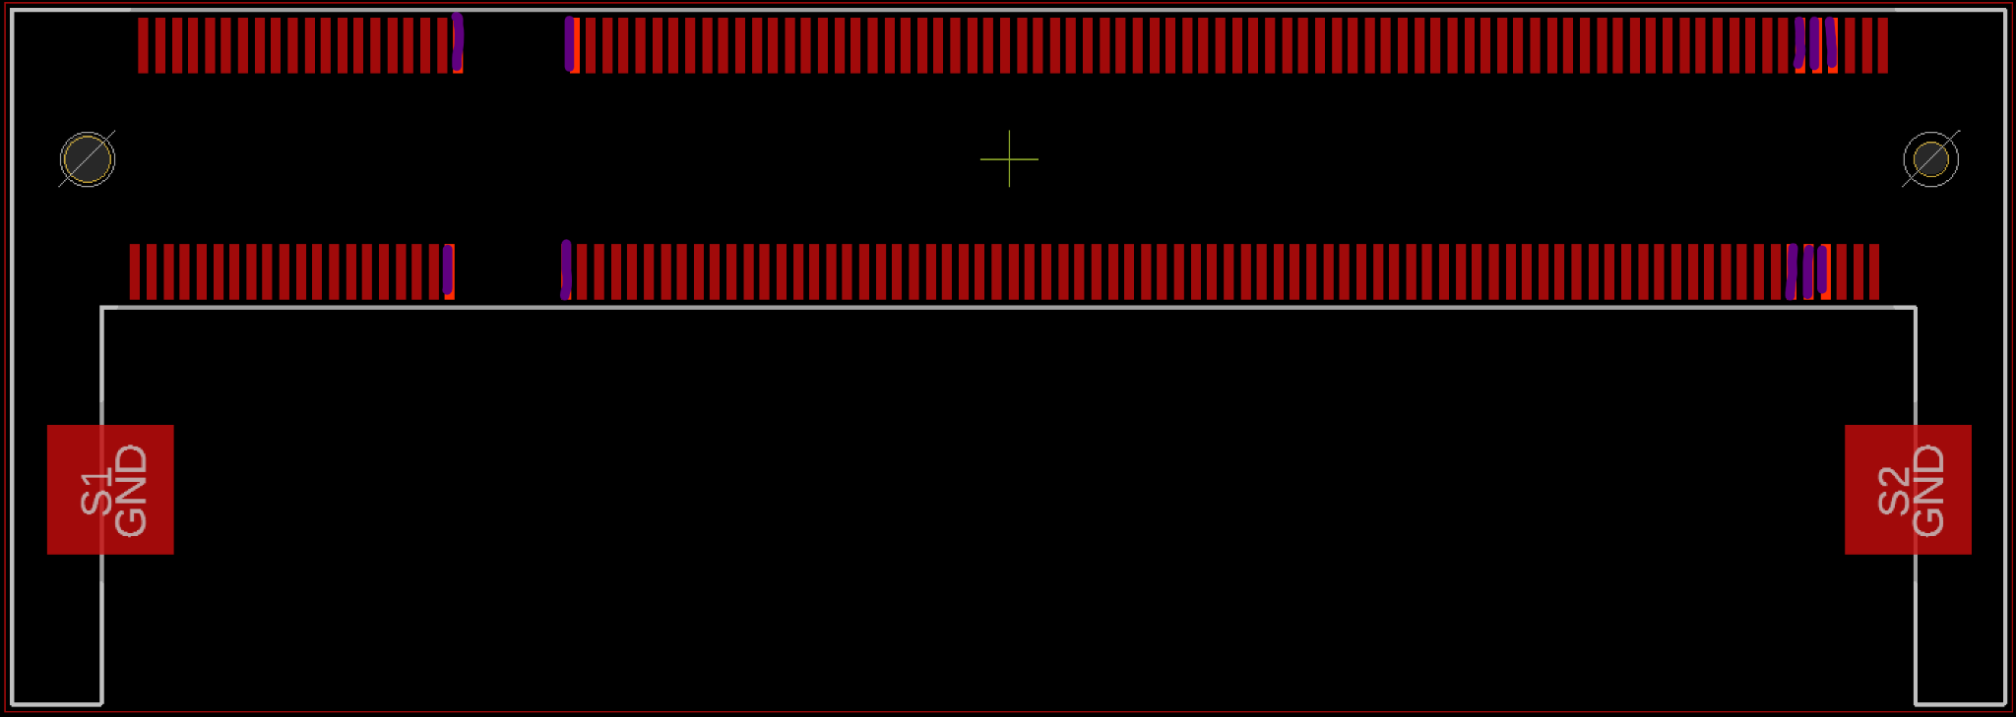

Fig. 5.46. Raspberry Pi Microprocessor 3.3V Probe Points (Colored in Purple)

For 1.8V power delivery to IMU and Raspberry Pi microprocessor, solder the 11.1V through hole to the 1.8V switching regulator breakout board and the 1.8V voltage input to the PCB through hole shown in figure 5.47 below.

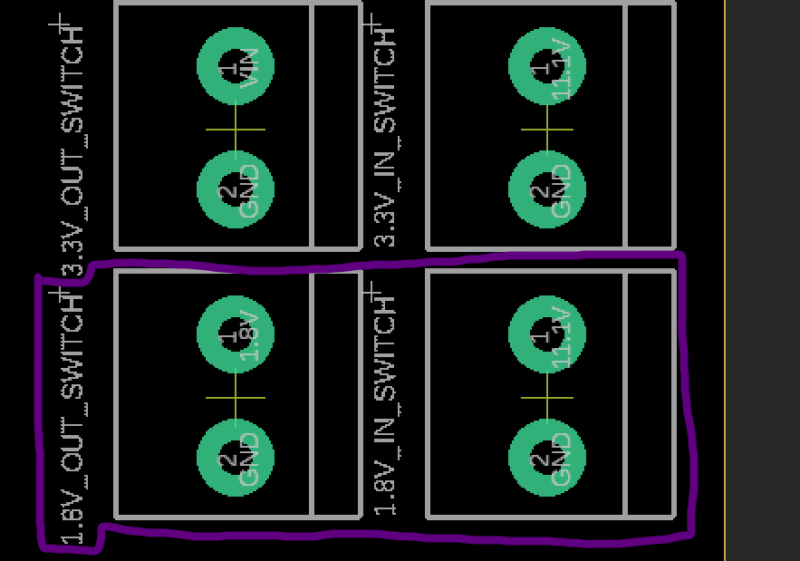

Fig. 5.47. 1.8V Switching Regulator Pinout

To verify that 1.8V is being supplied by the switching regulator to the IMU probe the IMU’s pins 8, 13, and 22 with the voltage meter and check for 1.8 volts, as well as probing the C14 bypass capacitor and the logic converters.

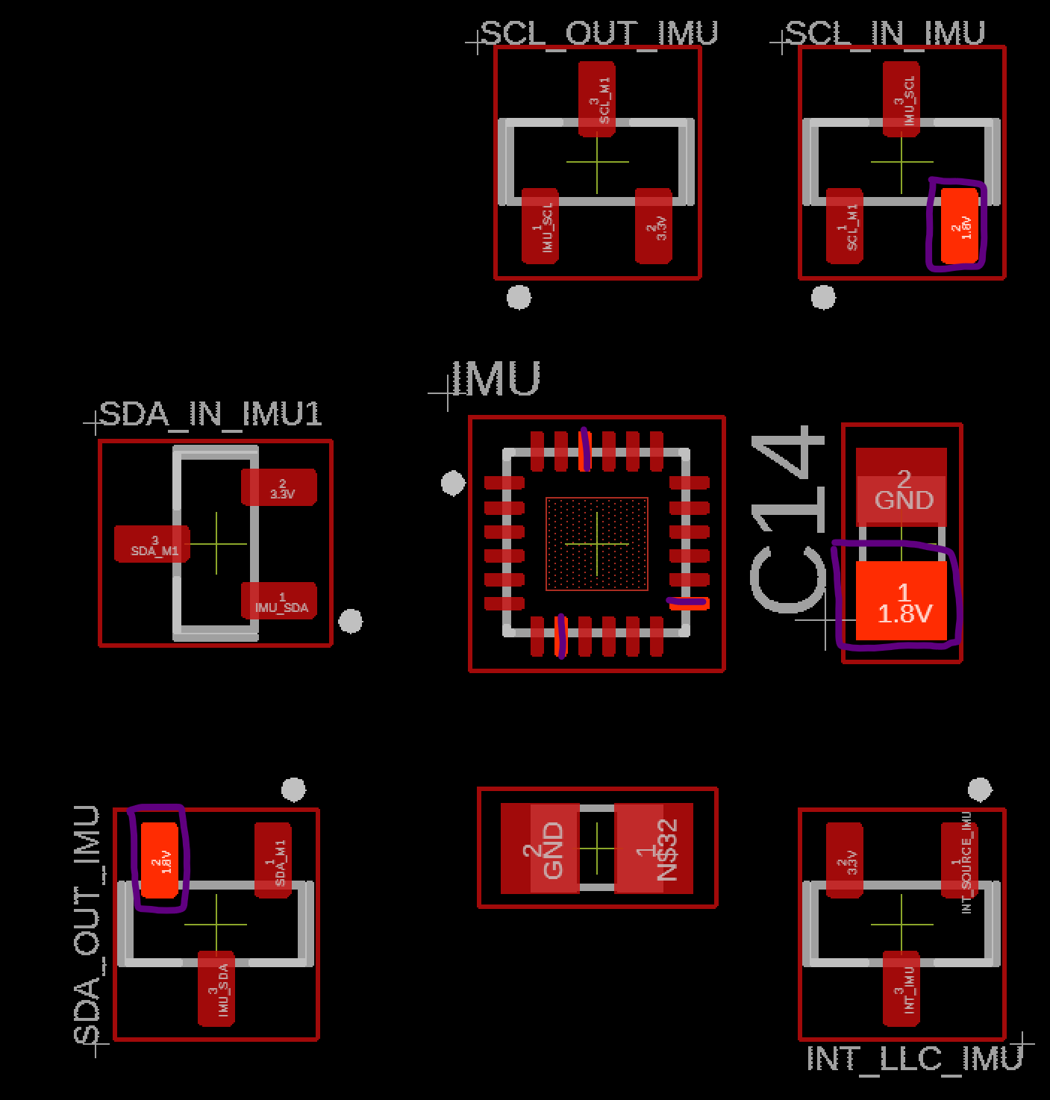

Fig. 5.48. IMU 1.8V Probe Points on Logic Converters, and Bypass Capacitor (Boxed and Colored in Purple)

The raspberry pi microprocessor also uses 1.8V, again probe the microprocessor’s pins 183-186 using the voltage meter and check for 1.8V in figure 5.49 below.

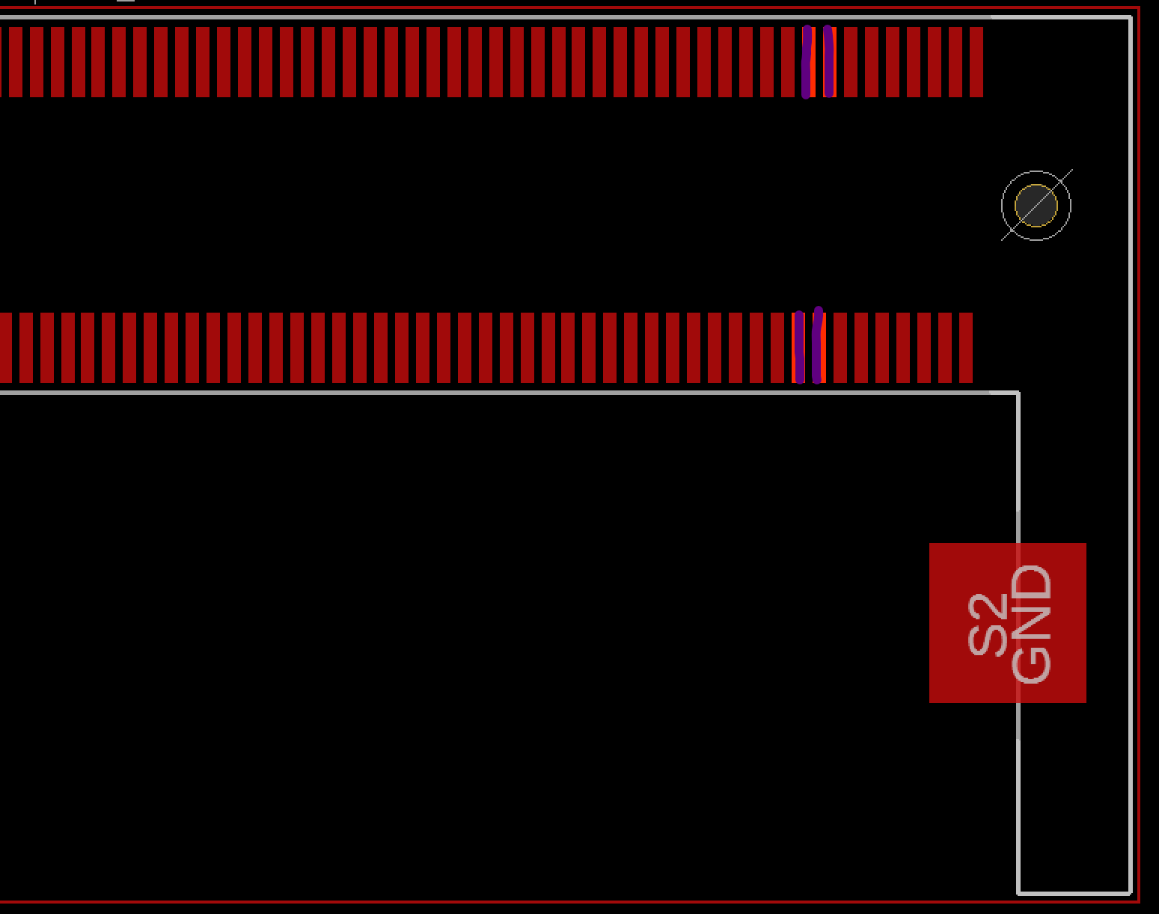

Fig. 5.49. Left Hand Side of Raspberry Pi Microprocessor 1.8V Probe Points (Colored in Purple)

5.3.8 I2C Bus Verification

Using the continuity function on the multimeter, check the I2C clock signal between the PIC32 microcontroller to the balloon pressure sensor, altimeter, and IMU as shown in figure 5.50 below. The multimeter, when set to continuity mode, should output a static beep sound when two probes are touching any two pads mentioned above. If there is no sound it means the trace is not connected and either the board house did not manufacture the PCB correctly or it is a design error where the engineer made a critical error in forgetting to place a trace path between the two pads.

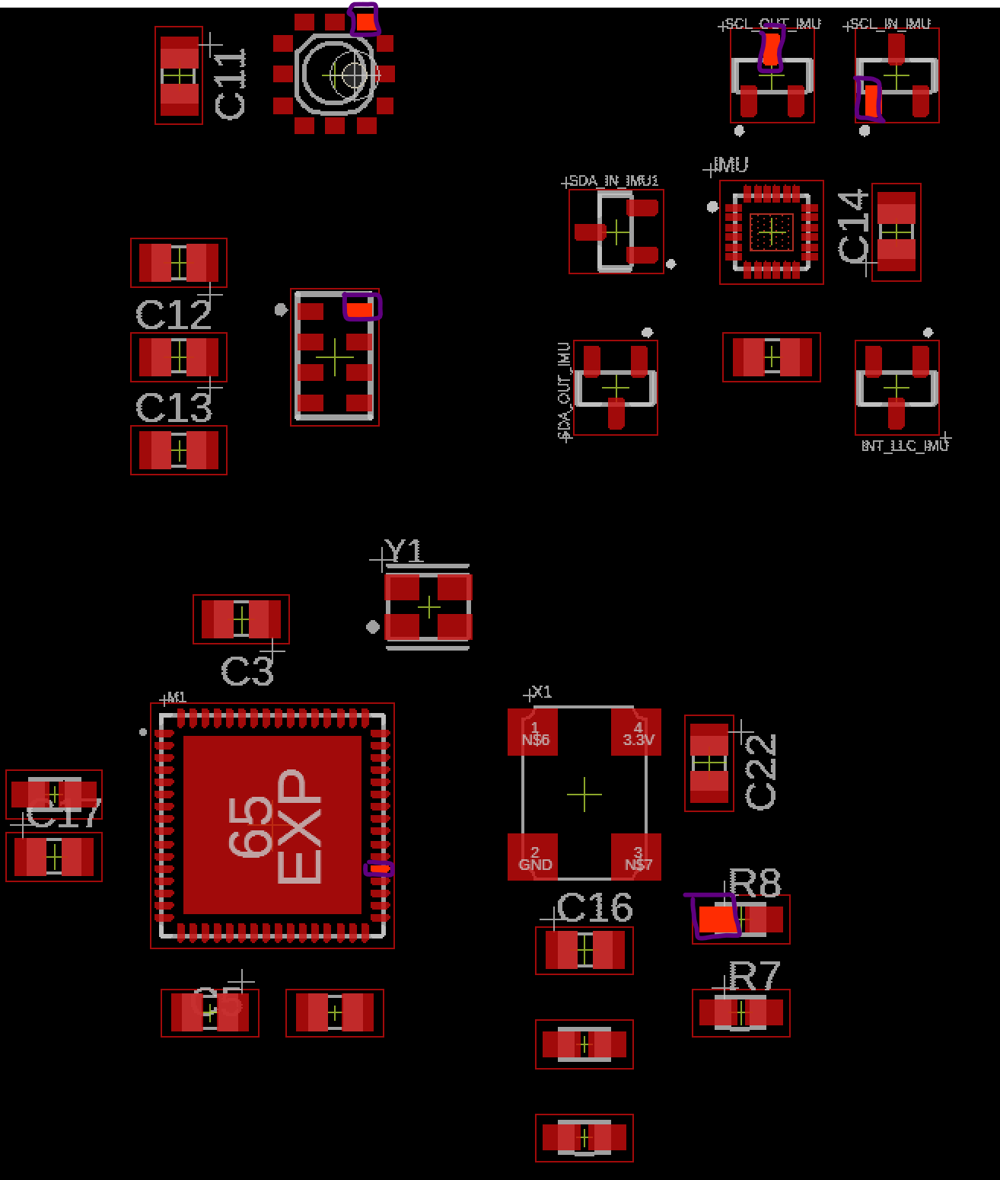

Fig. 5.50. I2C Clock Signal Test Points for Continuity Test (Boxed in Purple)

Check the continuity of the data signal or SDA between the microcontroller to the same sensor array as stated above in I2C Bus Verification subheading, as shown in figure 5.51 below.

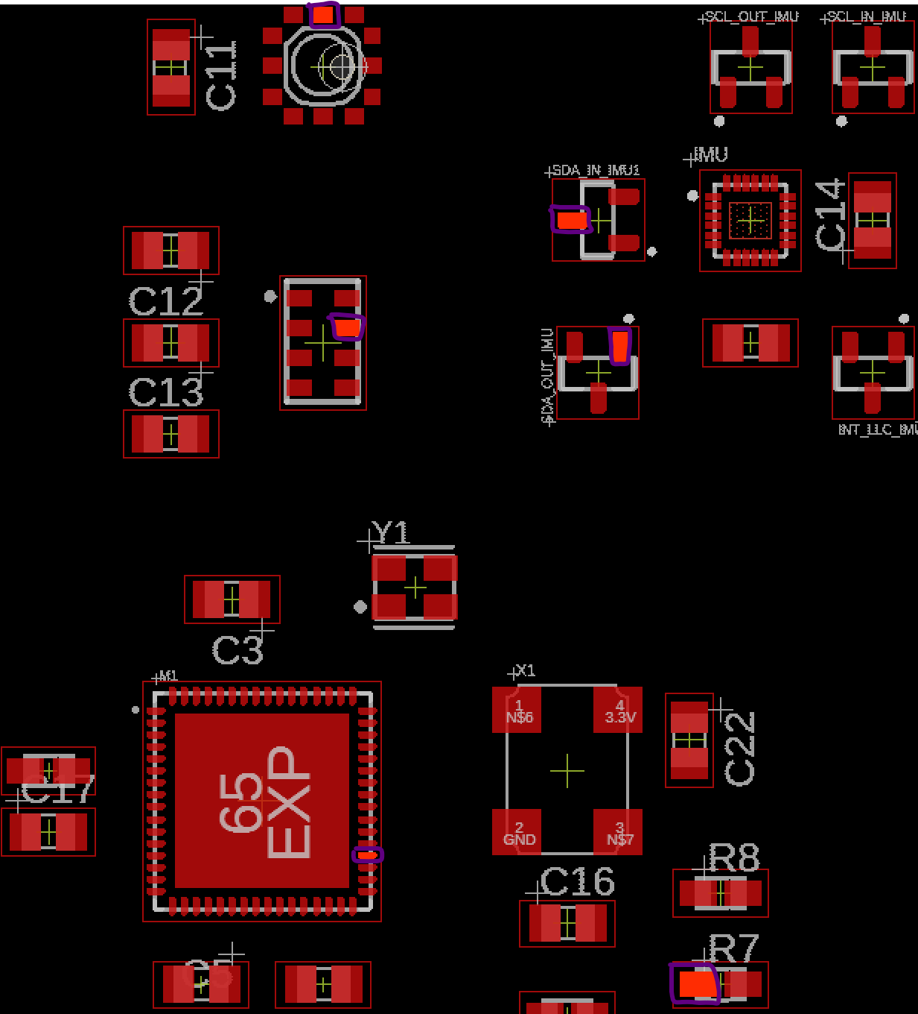

Fig. 5.51. I2C Data Signal Test Points for Continuity Test (Boxed in Purple)

5.3.9 UART Bus Verification

The UART signal bus from PIC32 microcontroller has two separate buses, first U1TX running to the GPS module and the second one U2TX running to the FTR232RQ UART to USB IC. To verify the traces are connected between them, set the multimeter to continuity mode and place the probes on the following pads shown in figure 5.52.

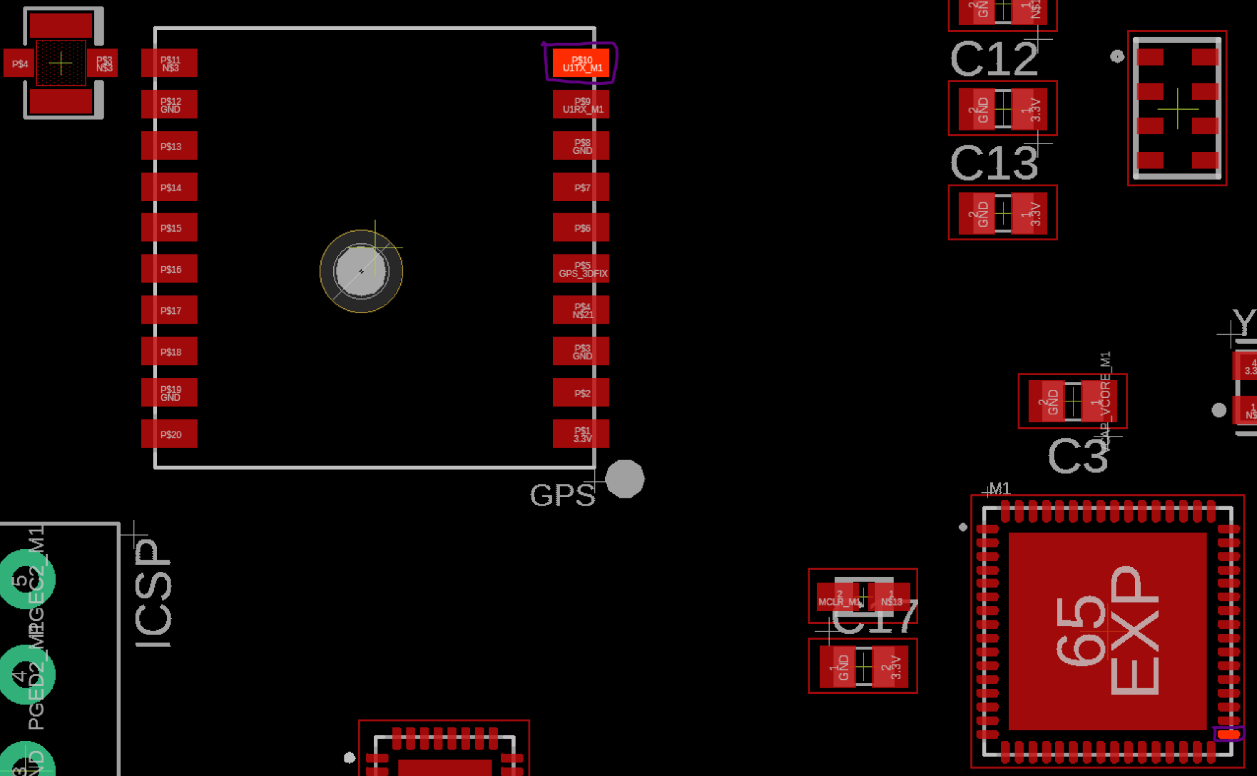

Fig. 5.52. UART Microcontroller Transmitter Continuity Test Point to GPS Module (Boxed in Purple)

Check the continuity of the RX of microcontrollers UART 1 with the GPS module as shown in figure 5.53 below.

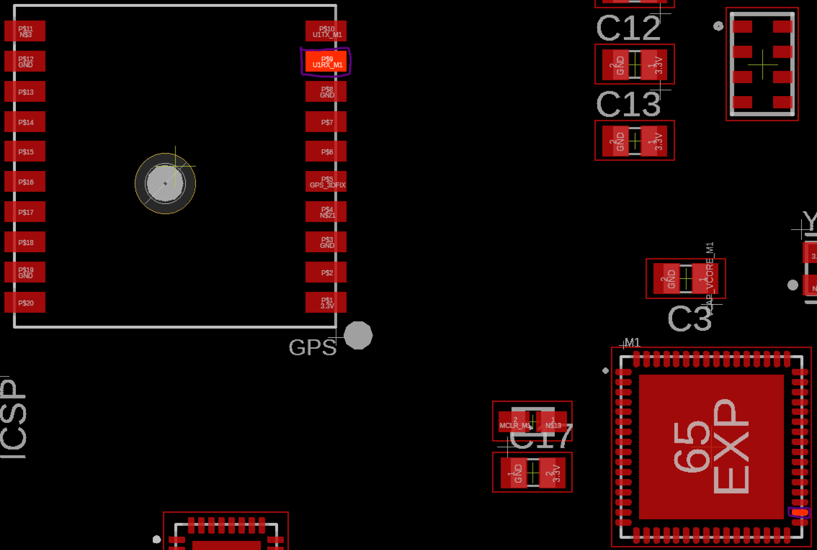

Fig. 5.53. UART Microcontroller Receiver Continuity Test Point to GPS Module (Boxed in Purple)

Now to verify the continuity of the second UART bus between the microcontroller to the FT232RQ UART to USB IC to make sure printf statements will work from the microcontroller to a personal computer serial terminal. Probe the transmitter pin of the microcontroller and the receiver pin of the UART to USB IC as shown in figure 5.54.

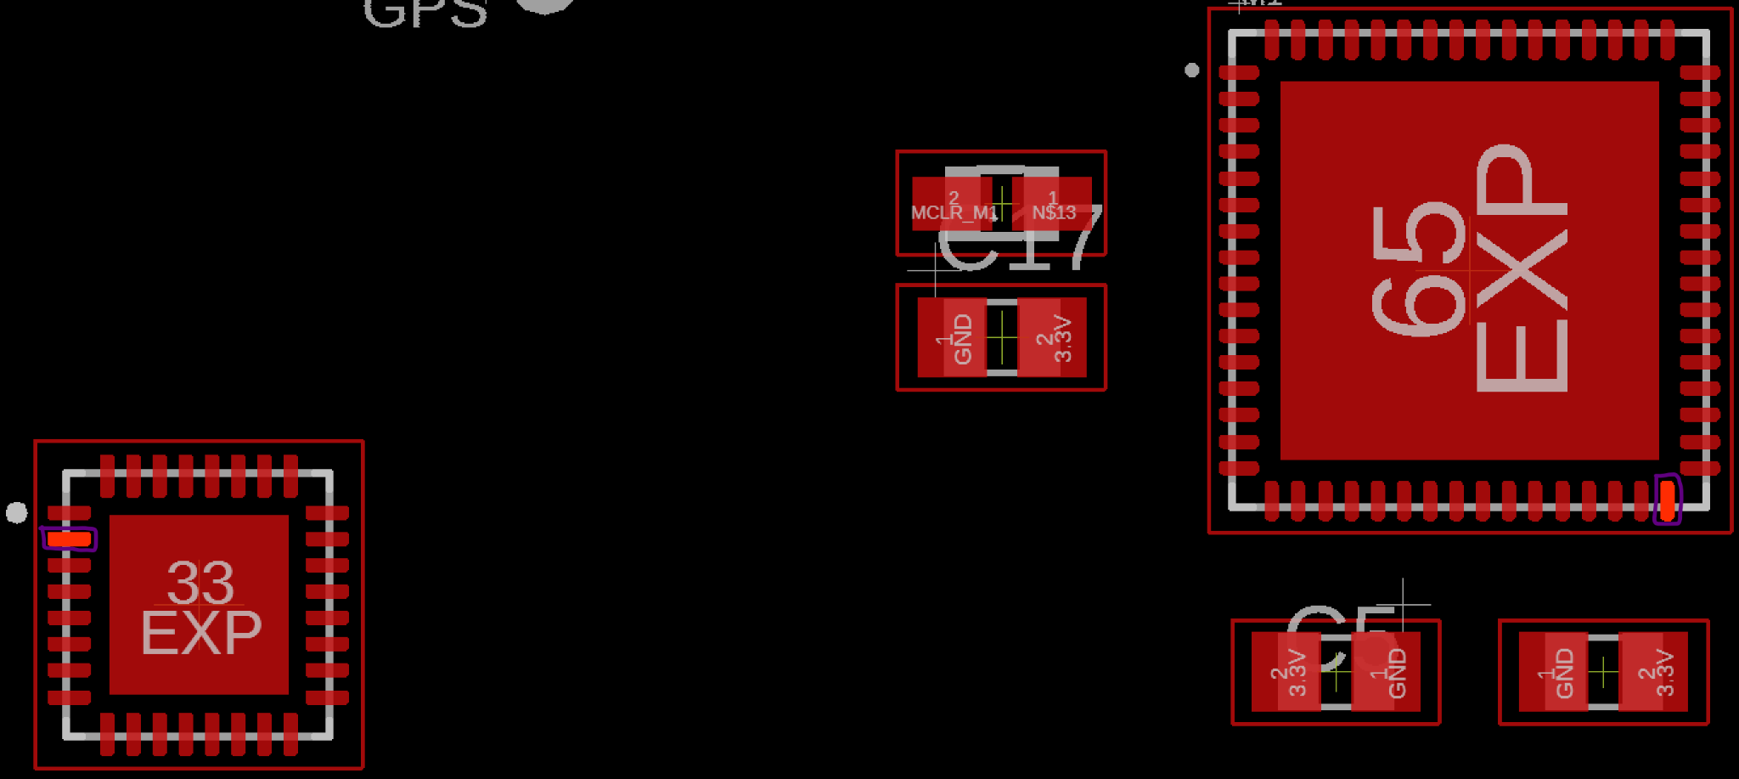

Fig. 5.54. UART Microcontroller Transmitter Continuity Test Point to FT232RQ IC (Boxed in Purple)

Next, verify the transmitter pad of the microcontroller and the receiver pad of the FT232RQ IC as shown in figure 5.55.

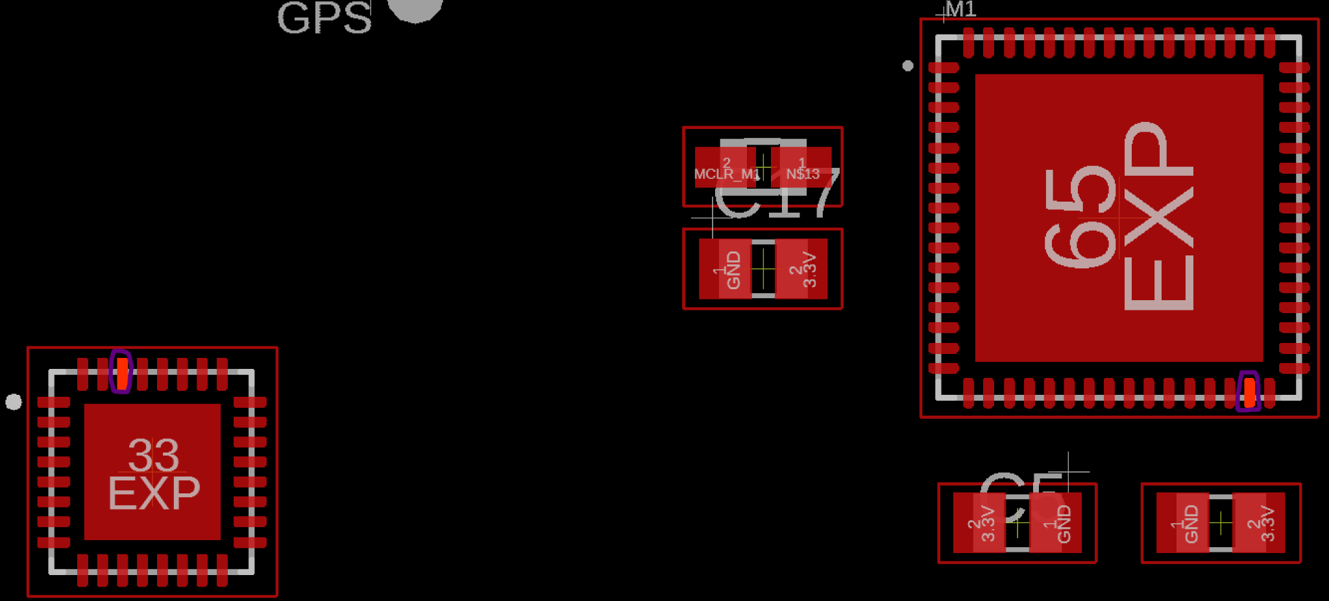

Fig. 5.55. UART Microcontroller Receiver Continuity Test Point to FT232RQ IC (Boxed in Purple)

5.3.10 SPI Bus Verification

The SPI traces connect the PIC32 microcontroller to the Raspberry Pi microprocessor and are connected by 4 signal traces, the MOSI, MISO, SCK, and CS. Verify the continuity of the MOSI trace by probing pin 33 of the Raspberry Pi microprocessor and pin 11 of the PIC32 microcontroller. Verify MISO trace by probing pin 29 of the Raspberry Pi microprocessor and pin 12 of the PIC32 microcontroller. Verify SCK trace by probing pin 35 of the Raspberry Pi microprocessor and pin 13 of the PIC32 microcontroller, and finally verify CS of PIC32 microcontroller is grounded since it is the only daughter device to the Raspberry Pi microprocessor parent.

5.3.11 Ultrasonic Sensor Signal Bus Verification

Using the continuity setting of the multimeter, probe the trigger pin of the first ultrasonic sensor named TRIG_SON0 shown in figure 5.56 below with pin 1 of PIC32 microcontroller, and probe pin 42 of the microcontroller with ECHO_SON0 pin of the ultrasonic sensor.

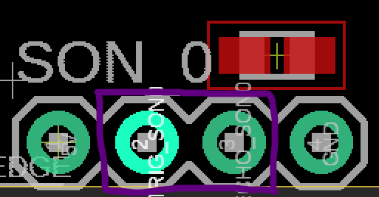

Fig. 5.56. 1st Ultrasonic Sensor Trigger and Echo Probe Point (Boxed in Purple)

Repeat the above steps for SON_1, SON_2, SON_3.

* SON_1
  + TRIG_SON1 probe with pin 2 of microcontroller
  + ECHO_SON1 probe with pin 43 of microcontroller
* SON_2
  + TRIG_SON2 probe with pin 3 of microcontroller
  + ECHO_SON2 probe with pin 44 of microcontroller
* SON_3
  + TRIG_SON3 probe with pin 4 of microcontroller
  + ECHO_SON3 probe with pin 45 of microcontroller

5.3.12 Actuator Verification

Verification of continuity between the servo and motor to PIC32 microcontroller. The test points for the motors and servos are shown in figure 5.57 below.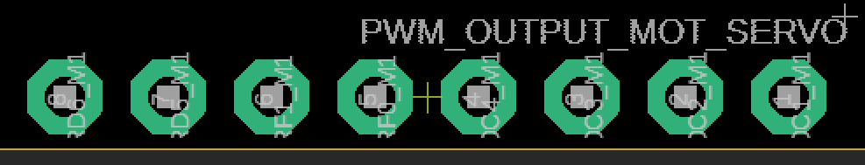

Fig. 5.57. Motor and Servo PWM Output Pinouts

Using the continuity setting of the multimeter, probe the following:

* Pin 8 of figure 5.57 with pin 54 of PIC32 microcontroller
* Pin 7 of figure 5.57 with pin 53 of PIC32 microcontroller
* Pin 6 of figure 5.57 with pin 59 of PIC32 microcontroller
* Pin 5 of figure 5.57 with pin 58 of PIC32 microcontroller
* Pin 4 of figure 5.57 with pin 51 of PIC32 microcontroller
* Pin 3 of figure 5.57 with pin 50 of PIC32 microcontroller
* Pin 2 of figure 5.57 with pin 49 of PIC32 microcontroller
* Pin 1 of figure 5.57 with pin 46 of PIC32 microcontroller

After the traces for each of the PWM traces have been verified, use a 8-channel logic analyzer and connect each of the probes to the pinouts on figure 5.57. Plug in the 11.1V battery and the logic analyzer should be able to read the periodic high time of the PWM pins.

## 5.4 Conclusion

After choosing the ultrasonic, IMU, altimeter, GPS, and air pressure sensors to meet system level requirements, the PIC32 and Raspberry Pi were able to be chosen to account for those sensors. Then, the sensors were tested with the PIC32, and the ultrasonic, IMU, and altimeter were verified to be within their requirements. The GPS, while functioning, was not as precise as it should have been, and the air pressure sensor was not implemented and tested.

PCB design for V2.0 includes design considerations for a dense IC board from Henry Ott’s textbook “Electromagnetic Compatibility Engineering”. 4 layer design allows return paths for high frequency components such as clocks, I2C signal bus, UART, and SPI by having the ground plane underneath the signal trace. Locations for power and signal components were considered in V2.0 PCB to reduce EMI between the microcontrollers, microprocessors and the sensor array from the voltage regulators.

Incremental verification methods are introduced but not executed. Verification is done with power rails first to ensure the rest of the system can be verified since sensors and microcontrollers must have power delivered to them for verification methods to be executed.

# 

# 

# 

# 

# 

# 

# Chapter Bibliography

[21]

ELEC Freaks, “Ultrasonic Ranging Module HC - SR04”, NA, NA

<https://cdn.sparkfun.com/datasheets/Sensors/Proximity/HCSR04.pdf>

[22]

NXP Semiconductors, “MPL3311A2”, NA , April 12 2018

<https://www.mouser.com/datasheet/2/302/MPL3115A2-1127148.pdf>

[23]

InvenSense, “ICM-20948”, DS-000189, June 2 2017

<https://invensense.tdk.com/wp-content/uploads/2016/06/DS-000189-ICM-20948-v1.3.pdf?ref_disty=digikey>

[24]

GlobalTop Technology, “MT3339”, FGPMMOPA6H, Jan 31 2012

<https://cdn-shop.adafruit.com/datasheets/GlobalTop-FGPMMOPA6H-Datasheet-V0A.pdf>

[25]

Honeywell, “MPRLS0001PG00001C”, 32332628, NA

<https://sensing.honeywell.com/honeywell-sensing-micropressure-board-mount-pressure-mpr-series-datasheet-32332628-en.pdf>

[26]

Brad Suppanz, PCB Trace Width Calculator, Advanced Circuits, 2018.

<https://www.4pcb.com/trace-width-calculator.html>

[27]

UltraCAD Design Inc., “Using the IPC Temperature Charts”, NA, Jan 2001

<https://www.ultracad.com/using_ipc_temp_charts.pdf>

[28]

Henry W. Ott, Electromagnetic Compatibility Engineering 1st ed. New Jersey: Wiley, 2009, pp. 624-625.

[29]

Henry W. Ott, Electromagnetic Compatibility Engineering 1st ed. New Jersey: Wiley, 2009, pp. 638-639.

[30]

Henry W. Ott, Electromagnetic Compatibility Engineering 1st ed. New Jersey: Wiley, 2009, pp. 106-107.

[70]

*Ultrasonic Ranging Module HC - SR04*, <https://cdn.sparkfun.com/datasheets/Sensors/Proximity/HCSR04.pdf>

[71]

*Section 24. Inter-Integrated Circuit (I2C)*, <http://ww1.microchip.com/downloads/en/devicedoc/61116f.pdf>

[72]

*Xtrinsic MPL3115A2 I2C Precision Altimeter - Data sheet*, <https://cdn-shop.adafruit.com/datasheets/1893_datasheet.pdf>

[73]

*DS-000189-ICM-20948-v1.3.pdf*, <https://cdn.sparkfun.com/assets/7/f/e/c/d/DS-000189-ICM-20948-v1.3.pdf>

[74]

*PMTK command packet-Complete-A11*, <https://cdn-shop.adafruit.com/datasheets/PMTK_A11.pdf>

[75]

*PIC32 Family Reference Manual – Section 21. UART*, <http://ww1.microchip.com/downloads/en/DeviceDoc/61107G.pdf>